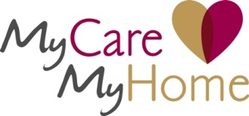

My Care My Home: Advice about care options and care funding

Dates: 30 June 2014

Times: 11:00am-12:00am or 1:00pm-2:00pm

Venue: Building 2, North London Business Park

Social care is changing fast and under the Care Bill from 2015, all councils will have a legal responsibility to provide information and advice about care and care funding. Getting good quality advice and information about care is important for people needing care and their carers.

This course will provide staff with the opportunity to learn more about the work of My Care My Home. My Care My Home helps people to navigate the care system, providing advice on: paying for care; finding the right care provider; options on the different types of care. Over the last year, nearly two hundred Barnet residents have sought advice from My Care My Home.

Who should attend? Barnet Front Line Staff, staff who have day-to-day contact with clients or their carers who want advice about care options and funding.

By the end of the course participants will:

- Have an understanding of the services provided by My Care My Home, how they can assist you in your day-to-day work.

- Know how to get advice and when to refer clients to My Care My Home
.

Trainer: Yasmine John , Tess Davies (My care My Home) & Gary Johnson, Customer Finance manager

To apply:
Click here to complete our online booking form, giving details of the course and date you want to attend.

Telephone 020 8359 6398

