RENTAL DETAILS

Community space (D1), ground and first floors

Golders Green Library, 164 Golders Green Road
London NW11 8HE

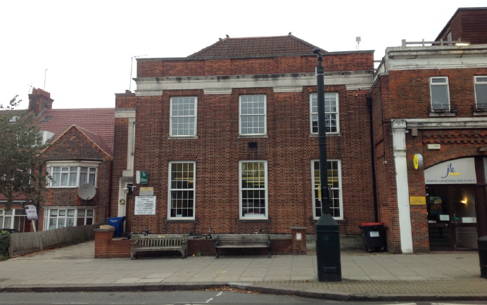

The lettable area consists of ground and first floor space totalling 161.24 sq.m.

Location

The property benefits from good public transport facilities the nearest tube station located 0.3 miles to the east of the subject at Golders Green. There are also a high number of bus routes located in close proximity to the subject.

The property is located on the edge of Golders Green Town Centre, the wider area is as a whole is characterised by medium density suburban residential housing. The area benefits from a number of local amenities. The area is well located to a number of schools and health care facilities.

Lettable area description

Please see the lettable areas coloured yellow on the attached pdf.file.

In summary the two floors are self-contained, newly refurbished; centrally heated space on ground and first floors. The lettable area has had a new DDA compliant lift installed

Note- The ground floor is 75% occupied by a public library

Location plan
Please see appendix 1
Planning
The property has formally been used as library space and has an established D1 use. Other uses are subject to planning approval. It is advised that all proposals are discussed before submission both with Barnet Council’s Local Planning Authority (020 8359 4974 and 4720 respectively).

Rental terms
By negotiation
Plus a fair proportion of service charges.
Depending on levels of interest, the council envisages holding an Open Day towards the end of February 2018.

Costs
The prospective purchaser or tenant will be responsible for the Council’s legal and surveyor’s fees.
Further Information in regards to this property please contact :
Alex Hill – Barnet Estates/Property Services | 0208 359 2774
London Borough of Barnet  Barnet House, 1255 High Road, N20 0EJ. | Alex.hill@barnet.gov.uk

General Information
1. The areas and measurements contained within these particulars are approximate figures only and no warranty is given as to their accuracy. The prospective tenants should satisfy themselves as to site areas and other matters of measurement from their own inspections and surveys. These details do not form part of any contract.
2. All statements made herein are made without responsibility on the part of the London Borough of Barnet and its employees, and should not be relied upon as statements or representations of fact. Prospective tenants must satisfy themselves by inspection or otherwise as to the correctness of each of the statements contained in these particulars.
3. The London Borough of Barnet and its employees do not give any warranty whatsoever in relation to the property.
4. The property will be leased as seen with all latent and patent defects and neither the London Borough of Barnet nor its employees warrant that it is suitable for any proposed use.
5. In no case shall any prospective tenant have any claim for expenses incurred in the preparation of any offer, nor in respect of any other matter.
6. The Council is not obliged to accept the highest or any offer received.

Appendix 1
