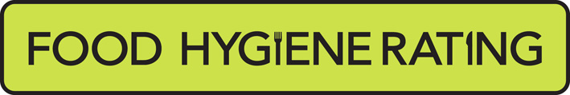  Food Hygiene Rating Scheme:  Appeal form |  | 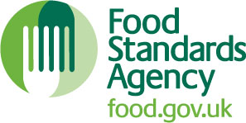

Notes for businesses:

- As the food business operator of the establishment you have a right to appeal the food hygiene rating given following your inspection if you do not agree that the rating reflects the hygiene standards and management controls found at the time of the inspection.
- You have 14 days (including weekends and bank holidays) from the date of receipt of the notification letter to lodge an appeal.
- Please use this form and return it to the Food Team at the address below.
- We will review your rating and send you an electronic response within 7 days. Letter responses may take longer as they will be sent by second class mail

Business details
Food business operator/proprietor

Business name

Business addresses

Business tel. number |  | Business email

Inspection details
Date of inspection |  |  | Food hygiene rating given
Date notified of rating

Appeal
I do not agree with the food hygiene rating given by the food safety officer because (please explain below under each of the three headings).

Compliance with food hygiene and safety procedures

Compliance with structural requirements

Confidence in management/control procedures

Name |  | Signature
Position |  | Date
If you would like any assistance completing this form, please contact the Food Team at foodsafety@barnet.gov.uk
Please now return this form to: Food, Health and Safety Team, London Borough of Barnet, Barnet House, 9th Floor, 1255 High Road, Whetstone, N20 0EJ
How your information will be used

Barnet Council will collect and use the information you give us to undertake our functions as a local authority and deliver services to you. It is our responsibility to ensure that your information is kept safe. Where necessary and legally allowed, we will share your information with trusted external organisations, commissioned partners and contracted service providers in order to deliver services and support to you.

The information we collect may be used to better understand your use of our services and assist us in improving our services. This is to ensure we are using public funds in the best possible way. Under our duty to protect public money we may use the information you have provided for the prevention and detection of crime.
For further details of how we use your information and to understand your rights please visit www.barnet.gov.uk/privacy or email data.protection@barnet.gov.uk to request a full copy of our privacy notice.

