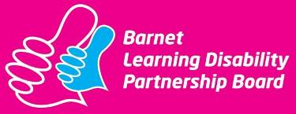

Learning Disability Partnership Board

Minutes

Meeting on 09th December 2014, 12.30pm – 4.30pm
Committee Room 1, Hendon Town Hall.
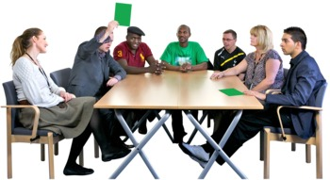

Present
Karen Morrell | Head of Integrated Care: Learning Disabilities and Mental Health (LDPB Co-chair)
Mahmuda Minhaz | People’s Choice (LDPB Co-chair)
Ray Booth | Chair of the Carer’s Subgroup
Steyn Crous | Healthwatch Barnet
Bernice Davis | Chair of the Housing Subgroup and Voluntary Sector Representative (Business Meeting only)
Rhoda Fynn | Carer Representative
Shelley Gibbons | Co-Chair of Day Opportunities and Community Inclusion Subgroup
Richard Harris | Chair of the Speaking Up Subgroup
Gill Fosler | Volunteer, BCIL
Maria Nash | Carer Representative
Chhaya Saha | Carer Representative
Anthony Nicholson | Carer Representative
Phillip Rackham | Service User
George Christodolou | Carer Representative
Lizzie Reeder | LD Parliament
Sue Tomlin | Joint Commissioning Unit
Ruth Carter | Service User Rep
Shilpa Shah | Peoples Choice
Andrea Constantinou | Peoples Choice
Molly Rayment | Chair of Health Development Subgroup
Sandy Littman | Carer Representative
Alan Mordue | Care Act Project Manager
Perpetua Kamwendo | Joint Commissioning Unit
Apologies
Susan Hawthorne | Healthwatch Barnet
Betzalel Lifschitz | Service User
Kevan Hall | Service User Rep

1.   | Welcome, Apologies and Introductions  Mahmuda welcomed everyone to the meeting.  Hannah told everyone about the people who had apologised that they couldn’t be there today.
2.  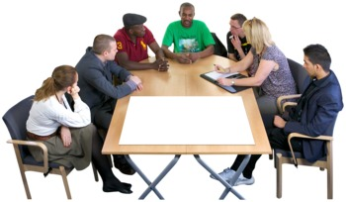 | Workshop: Care Act  Alan Mordue, Care Act Project Manager did a presentation to everyone on the changes the care act would be making.  He told everyone about the 9 Rules of how we must treat people.  He told everyone about how the government had made a change to the eligibility criteria but that it was expected that this would not make a big difference to the people who receive care as it was expected that everyone who currently received care will still receive care.  He told everyone about that we must provide people who need it with advocacy services and how this will be provided in Barnet  He also told everyone about what the Care Act says we must do to make sure everyone has information and advice and how this will be provided in Barnet.  Everyone split into 4 groups and 2 groups looked at Advocacy and 2 groups looked at Information and Advice.  The groups wrote down what good services would look like in Barnet. The notes from the workshop can be found in the appendix at the end of the minutes.
BUSINESS MEETING
2.  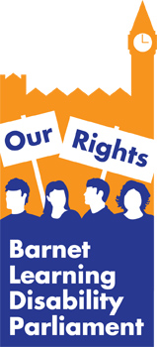 | Learning Disabilities Parliament Update  Lizzie gave the Parliament Report  - Brent Cross Disability Access Forum have not met due to a delay in the planning application  - The Parliament has discussed the consultation on Barnet’s Library Service and has sent the members views to Barnet Council  - In April the Parliament will be talking about the election and hopes to invite some people to speak about this.
1.   | Sub Group Updates  Carers -Ray Booth, Chair of the carers sub group told everyone about a new Parent carers group that had been set up and that Ray was looking at how they can make sure they can be involved with the work of the Partnership Board.  Ray told everyone that the sub group had been looking at how the care act will affect carers and that it would mean that carers have a new right to assessment.  Ray explained the sub group had contributed to the self-assessment framework form as they had not been happy and had scored red on the carers satisfaction question and also on the question about people with learning disabilities being treated with dignity and respect.  There had recently been some training for carers however this had not been well attended. People made some suggestions about things that may help including ensuring that meetings were held all around the borough.  Health – Molly Rayment, Health Sub group Chair introduced Tamara Mcnamara who is the new acute liaison nurse for Barnet and Chase Farm hospitals  Some work will be taking place with Tamara around how people who have a learning disability can be identified quickly when using hospital services. One suggestion is that if you do not want your name to be flagged then you would need to opt out.  Some work has now started on end of life planning and there has been continued work with GP to ensure the templates that were designed are working.  Molly advised that this would be her last partnership board as she would be retiring and the board thanked her for all of her hard work.
3. | Self Assessment Framework – Board Sign Off  Perpetua Kamwendo and Sue Tomlin, Joint Commissioning Unit, introduced the self-assessment framework that had now been completed.  It was explained that the questions were rated green for good, amber for needs more work and red for not doing very well.  Some of the questions were rated by the council with the evidence we have. Some were rated by carers and some will be rated by the data collected by Public Health England.  The board was told what areas had scored what colours  Some of the areas were rated red because it was difficult to collect the data needed. Work was starting already to make sure that this does not happen next year.
4. | Personal Health Budgets  Ray Booth, Mencap and Carers Sub Group Chair and Steyn Crous, Healthwatch introduced some work that is happening around Personal Health Budgets.  They told them about what these budgets are and how they are doing a piece of work to see how they may be used in Barnet.  At first only a few families will be offered the Personal Health Budgets and then they will see what worked well and what needs to be improved.  There will be a working group set up to make sure that the work goes well and Ray advised that if members of the board want to be a part of this then they should contact him.
5.   | Health and Wellbeing Boards Forward Work Plan: Obesity  It was highlighted that the health and wellbeing board would be looking at Obesity in the future and it was important that the board were able to feed in what was important to them about tackling obesity.  The board came up with suggestions including:  - GP’s need to highlight people with learning disabilities  - GP’s need to look at more creative ways to help people lose weight.  - Information needs to be in easy read format
6.  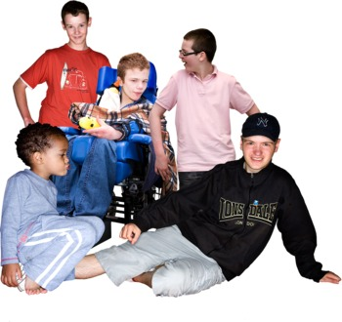 | Services for People aged 0-25  Kirk Chamberlain came to the meeting to tell the board about the work that is currently taking place  The work wants to make sure that lots of things don’t change in someone’s life all at once and so a service is looking at being provided that stays with people until they are 25.  Lots of the details have not been worked out yet and there will be lots of opportunity to feedback on the plans including a representative to be a partner in developing the service.  Some of the points raised by the board included:  - Speech and Language Therapists, Nurses and OT’s should be an essential part of the team  - The service will need to ensure that it is able to stop working with people as though they are children post 18  - Concerns that this may be moving the changes from 18 to 25 but not managing them effectively.  - There should be a mechanism to partner up people who have been through transitional services with people who are going through it.  - 6 weeks is not long enough for a consultation
7.  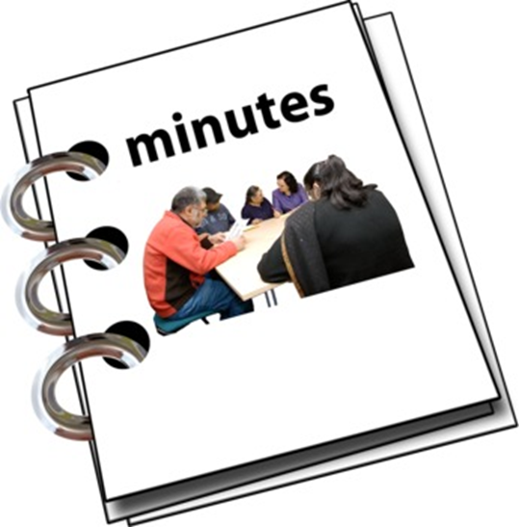 | Review of actions from draft minutes  The minutes were agreed.  The actions were looked at and any that had been completed were taken off the action log.
8.   | Any other business  There will be an epilepsy awareness meeing on 20th April and on the third week of each month. Contact Liz Reeder for more information  There will be Hustings on 27th March at St Pauls Centre, Long Lane in Finchley which will be an opportunity to find out more about the elections.
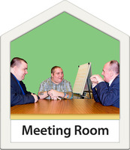  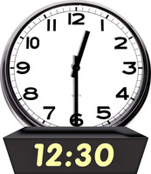 | Next meeting:  Friday 15th May  12:30 -4pm  Committee Room 1, Barnet House

LDPB Actions Log

Date Agreed | Action Number | What LDPB has agreed to do | Who will do this action
09th December 2014 | 1 | Karen to find out if the change in Benefits from DLA to PIP will have any impact on the Fairer Charging Policy. | Karen Morrell
16th September 2014 |  | Gary Johnson to provide an easy read briefing on the ILF changes to LDPB | Hannah Ufland
Date Agreed | Action Number | What LDPB has done.  (All these actions have been done.) | Who has done this action
18 March 2014 | 4 | Think about what subgroups can do to make things better for family carers when developing their workplans. | Subgroup chairs
17 June 2014 | 3 | Let Ray or Karina know things we can do to get more people to come along to subgroups. | Everyone
09th December 2014 | 6 | Board members to tell Hannah what they think is important for the Health and Wellbeing board to know. | All members
09th December 2014 | 5 | Hannah to provide feedback from the communications team if they can support with this. | Hannah Ufland
09th December 2014 | 4 | Hannah to send out where online courses can be found in the borough as part of the monthly update. | Hannah Ufland
09th December 2014 | 3 | Hannah to feedback request to the communication team about using twitter to spread the message of the partnership boards. | Hannah Ufland
09th December 2014 | 2 | Karen to invite Kirk to speak to the Board at the next meeting about the 0-25 service. | Karen Morell

Appendix 1

Care Act Workshop

Information and Advice – What is a good Service?

- Answering the phone quickly
- Making options to choose clear
- A directory of Information and Numbers
- Keeping Information and Telephone numbers up to date
- Options to drop in and have face to face support
- Having support for people with learning disability
- Using community navigators – People who can gather and link together information
- Well trained people to provide the right information
- Using a variety of methods to make information and advice accessible
- Using a variety of community venues to access information and advice
- Support to get specific and individual information and advice not just general options
- Clear publication of when and how information and advice can be received
- Ensure that people have a clear understanding on how to communicate with people with Learning Disabilities
- Monitor the outcomes of people looking for information and advice and how satisfied they are
- Use existing community groups to share information
- Use health settings such as Hospitals and GP surgery

Advocacy – What is a good service?

- Advocacy should be run by people who have personal experience for example people with Learning Disabilities
- Should have knowledge of the wide range of issues that affect people with learning disabilities
- Use simple language and no jargon
- Needs to have knowledge of the law and understanding peoples rights
- Can work on a long term basis with people
- Not to have a long waiting list
- Be able to use the same advocate who already knows you
- To be able to drop in
- Needs to be responsive as cannot always plan when you may need the service
- Should be able to also offer information and advice
- Experience of working with people with a learning disability
- Advocacy must be well promoted
- People should be told what to expect from the service
- To support campaigns for people with Learning Disabilities such as changing places and Mencaps getting it right

