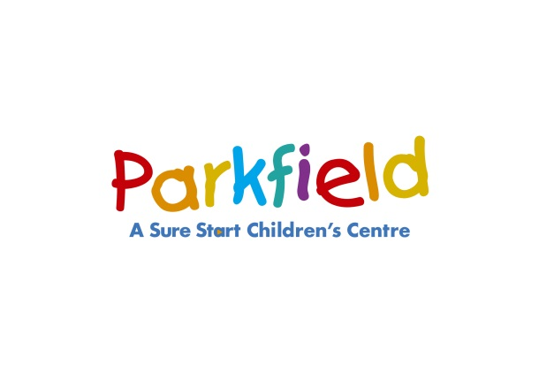BARNET_logosm South Locality 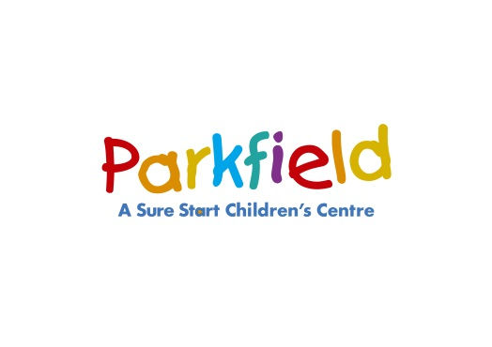

**Summer Holiday Programme 23/07/2018 – 17/08/2018**

**Parkfield Children’s Centre, 44 Park Road, Hendon NW4 3PS**

**Tel: 020 8359 3590 emails: info.parkfieldcc@barnet.gov.uk**

|  |  |  |  |  |
| --- | --- | --- | --- | --- |
| **Monday** | **Tuesday** | **Wednesday** | **Thursday** | **Friday** |
| **Antenatal Clinic**  9am – 1pm  (Bookings:  020 7794 0500  Ext: 36169) | **Antenatal Clinic**  9am – 3pm  Fortnightly  (Bookings:  020 7794 0500  Ext: 36169) | **Antenatal Clinic**  9am – 3pm  (Bookings:  020 7794 0500  Ext: 36169) | **Antenatal Clinic**  9am – 3pm  (Bookings:  020 7794 0500  Ext: 36169) | **Antenatal Clinic**  9am – 1pm  (Bookings:  020 7794 0500  Ext: 36169) |
| **Every Child A Talker**  Stay and Play  9.15 – 10.45am  Speech & Language focused play for children  **Walkers to Under 5yrs Only** | **Sensory Baby**  10.30am – 11.30pm  Sensory Play for babies  Topic includes  Tummy time  Early communication  Oral health  Weaning  Bonding & Attachment  **Non-walkers** | **Teddy Bears Picnic**  **10am – 2pm**  **Hendon Park**  Please bring your Teddy’s and picnic  **25/07/18** | **Baby Massage**  11.15am – 12noon  (bonding session for parents/carers and babies 8 weeks to 6 months)  **Call to book** |
| **Play in the Park**  **10am – 2pm**  **Golders Hill Park**  Join us in the fun with your spade and buckets  **01/08/18** | **Hop Skip & Play**  2 – 3pm  Physical play session to develop  Co-ordination  Balancing  Core strength  Concentration  Movement skills  Positive interaction  **Walkers to Under 5yrs** |
| **Baby Rhyme Time**  12.30 – 1pm  **Non-walkers** | **Unity Antenatal Clinic**  10am – 4pm  Contact Fatmatu on: 07919990347 | **Messy Play**  2 – 3pm  Have fun getting messy and exploring a range of different sensory materials  **18m – under 5’s Only** |
| **Breastfeeding Support Drop-In**  1.30 – 3.00pm  Includes weaning and feeding advice | **Parent Education Workshop for expectant parents**  12.30 – 2.30pm  (for dates please contact: Royal Free Hospital**)** | **International day Parkfield CC**  **10am – 2pm**  **08/08/18**  **International food available**  **Tickets £2per person**  **Children under 5’s go free – limited numbers** |
| **Child Health Clinic**  1.30 – 3.00pm  Last sign in 2.45pm  (contact health visitor:  020 8205 6204) | **Information and Advice Surgeries**  **Services include:** \*Welfare Rights  Advice  \* Speech and  Language sessions  \* School Transitions \*SENCO Surgeries  \* Counselling  services –by  referral  \* Employment  support  \*Volunteering  \* Food Bank  vouchers |
| **Postnatal Clinic**  1:30 – 3:30pm  (for dates please contact: Royal Free Hospital**)** | **Holiday Stay & Play**  3:00 – 4.30pm  Play together session for children under 5’s | **Sports day at**  **Hendon Park**  **10am – 2pm**  **15/08/18**  Bring you picnic |
| **Development Checks**  1.30 – 4pm  By appointment only |
| **South Locality Children’s Centres**  We work in partnership to offer a range of services with other children's centres in our locality  **Bell Lane Children’s Centre,** Bell Lane, Hendon NW4 2AS Tel: 020 8203 3115  **Child's Hill Children’s Centre,** Greenfields Gardens, Cricklewood NW2 1HX, 020 8450-2141  **The Hyde Children’s Centre**, Hyde Crescent, Colindale, NW9 7EY, 020 8200-2959  **For further information please go to www.barnet.gov.uk to view their timetables.**  **The centre will be closed from Monday 27th August through to Monday 03/09/18** | | | | |

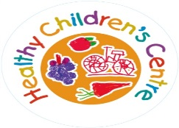



**Summer Holiday Programme 23/07/2018 – 17/08/2018**

**The Hyde Children’s Centre**

**Hyde Crescent, London NW9 7EY**

**Tel: 020 8200 2959 email:** [**info.hydecc@barnet.gov.uk**](mailto:info.hydecc@barnet.gov.uk)

|  |  |  |  |  |  |  |
| --- | --- | --- | --- | --- | --- | --- |
| **Monday** | **Tuesday** | **Wednesday** | **Thursday** | | **Friday** | |
|  | | | | | | |
| **The Hyde Children’s Centre is closed on Mondays** | **Developmental checks**  9am – 12.00  Appointment only  (Barnet Health Team) | **The Hyde Children’s Centre opens at 12.30pm on Wednesday** | **Child Health clinic**  (contact health visitor:  020 8205 6204)  **9.30 -11.15am**  Last sign in 11 am | | **Midwife services**  9am – 4.30pm  Appointment only | |
| **Speech & Language Therapist Surgery**  9.30 – 11.30am  Dates to be confirmed  **Strictly by Invitation** | **Baby Stay & Play**  9.30 – 11.15am  **0 – 24 Months**  Fun sessions with different play activities, sand, water, painting, drawing, singing and rhymes | | **Messy play**  9.30 – 10.30am  Promotes creativity and sensory development  **0-24 Months** | |
| **Healthy Start Vitamin Collection**  Bring in your vouchers to collect vitamins | **Developmental checks**  12 – 1.30pm  Appointment only  (Barnet Health Team) | |  | |
| **Sensory Room**  **Available on Tues am and Wed pm**  Call to book your session  £2 per 30min.  For children  0 – 12months | **The Hyde Children’s Centre closes at 12.00pm on Tuesday** | **Midwife services**  12.30 – 4.30pm  Appointment only |
| **Chatty Play**  **1.30 – 2.15pm**  **&**  **2.30 – 3.15pm**  Language enrichment group  **Strictly by invitation** |
| **Planned Closures**  **The centre will be closed from Monday 27th August through to Monday 03/09/18** | | | | | | |
| **Additional activities provided from our Outreach Venues across our locality** | | | | | | |  |
| **London Jewish Family Centre**  **Baby Clinic**  **10am - 12noon**  Opportunity to weigh your baby and get advice from health visitors team  Children Centre Staff will be present to give information on different services as appropriate  **113b Golders Green Road London, NW11 8HR** |  |  | | **Child’s Hill Clinic**  **9.30am – 12.30pm**  Opportunity to weigh your baby and get advice from health visitors team  Children Centre Staff will be present to give information on different services as appropriate  **Garth Road**  **Cricklewood**  **NW2 2NJ** | |  |
| **Breast Feeding support**  Please call Parkfield on 020 8359 3590 for further information  **Speech and Language Therapy Surgery**  If your find your child is having difficulties with speech and /or language development please call and book an appointment with our Speech and Language Therapist   * For Parkfield Children’s Centre on 020 8359 3590 * For the Hyde Children’s Centre on 020 8200 2959 * For Child’s Hill Children’s Centre on 020 8450 2141   **Family support and Outreach services**  Our Outreach Team provides a range of Stay and Play activities. Family Support is able to provide advice and guidance in a variety of ways. The experienced team can visit you at home, provide telephone contact and or arrange meetings at the centre. Specialist support includes behaviour management, housing, benefits, breast feeding, weaning, sleep routines, toileting and healthy lifestyles.  Referrals to  external services are also available. | | | | | | |



**Summer Holiday Programme 23/07/2018 – 17/08/2018**

**Greenfields Gardens, Childs Hill NW2 1HT**

**Tel: 020 8450 2141 email****:** [**ChildsHill.ChildrenCentre@barnet.gov.uk**](mailto:ChildsHill.ChildrenCentre@barnet.gov.uk)

|  |  |  |  |  |
| --- | --- | --- | --- | --- |
| **Monday** | **Tuesday** | **Wednesday** | **Thursday** | **Friday** |
| Welfare Rights  Drop-in  9.30am–12noon  On the following dates  30th July  13th August  10th September  24th September  8th October  22nd October  Welfare &  Benefits advice | **Childs Hill Opens at 12.30pm on Tuesdays** | **Family Support Surgery**  **9.30-11.30am**  Confidential advice and support on the range of services available through the centre and our partner agencies  Workshops to be delivered by the BOOST TEAM  On various topics like  Confidence building  Interview skills  CV writing   |  |  | | --- | --- | | Please call the centre for more information  **No appointment needed** | needed | | **Childs Hill Opens at 12.30pm on Thursdays** | Child’s Hill Children’s Centre is closed on Fridays |
| **Developmental Checks**  10.00am – 12pm  2nd and 4th Monday of the month  **By appointment only**  **Term Time**  Call 020 8209 0333 | Antenatal Midwife Clinic  1 – 4.30pm  2nd & 4th Tuesday  By appointment only  Call 020 7830 2568 | **Breast Feeding Support**  Call Parkfield Children Centre to book 1:1 support with breast feeding  On  020 8359 3590 | **Antenatal Clinic**  12:30 – 4:00  By appointments only |
| **Childs Hill closes at 12pm on Wednesdays** | **Stop Smoking Support**  Please ask at the reception |
| **Unity Midwife Clinic**  9am – 4pm  **By appointments only** |
| **Planned Closures**  **The centre will be closed from Monday 27th August through to Monday 03/09/18**  **Please note: Timetable correct at the time of going to print – please contact the Centre direct for more up to date information** | | | | |