IVR Review
Customer Services
Revenues & Benefits

Owner | Author | Date of Issue | Version
Liv Brown | Jason Douglin | 12/01/2015 | V0.1

DOCUMENT LOCATION

APPROVALS

Name | Title | Signature | Date of Issue | Version
Mary Colorado | Contract Manager |  | 12/01/2015 | V0.1
Liv Brown | Service & Channel Development Manager |  | 12/01/2015 | V0.1

DISTRIBUTION

Name | Title | Organisation | Date of Issue | Version
Leanne Pitt | Assistant Contract Manager (Revenues & Benefits) | Capita | 12/01/2015 | V0.1
Lorna Moore | Assistant Contract Manager (Revenues & Benefits) | Capita | 12/01/2015 | V0.1
Mary Colorado | Contract Manager | Capita | 12/01/2015 | V0.1
Liv Brown | Service & Channel Development Manager | Capita | 12/01/2015 | V0.1
Tracy Osman | Customer Service Director | Capita | 12/01/2015 | V0.1

RELATED DOCUMENTS

Document Reference | Document Title | Date of Issue | Version
N/A | London Borough of Barnet (LBB) FDS v0 41 | 10/9/2014 | 0.41

Contents

1. Current Revenues and Benefits IVR 4
1.1. Current IVR Flow 4
2. Scope for Review 7
3. Service Analysis 7
3.1. Classification Usage 7
3.2. Call Volumes 11
4. Investigation Into Specific Areas within Council Tax 11
4.1. CTAX – Payment Taken – 9.86%of calls 12
4.2. CTAX - Arrangements CY SPAR – 9.29%of calls 13
4.3. CTAX Final Notice – 7.70%of calls 13
4.4. CTAX Change of Address (Out) – 6.69%of calls 15
5. Investigation Into Specific Areas within Benefits 15
5.1. Follow-Up Case Inside SLA – 19.77% of calls 16
5.2. Benefits New Claims Team – 8.38% of calls 17
5.3. Bens – Award Check – 8.28% of calls 17
5.4. Benefits Change of Circumstance – 8.21% of calls 18
6. Proposed IVR Changes 20
6.1. Revised IVR Flow 20
7. IVR website links analysis 26
8. Benefit Assumptions 26

Current Revenues and Benefits IVR

Current IVR Flow

Scope for Review
A review of the existing IVR (as documented in 1.1 Current IVR Flow) will be undertaken with view to:

- Improve customer journey
- Reduce contact volume to contact centre
- Promote Self Serve options in particular My Account Portal
- Make IVR more resilient
- Facilitate the use of Multi Skilled and Global advisors
- Increase agent utilization

This review will not form a business case for change other than the IVR changes proposed, however, will review merit for a larger scale service improvement project which will feed into the Root Cause Analysis projects targeted for completion this year. Where possible and there are no financial or resource implications for either party any smaller changes will be implemented prior any service review

Service Analysis

Classification Usage

Due to the limited skill sets in the current IVR, telephony data does not provide a segmented view of the call types received by the Revenues & Benefits team. To aim to quantify the call types, a review of classifications within LAGAN CRM has been undertaken focussing on the period April – December 2014.

To ensure the data set is as accurate as possible the following classifications have been removed from all totals and calculations:

- Any classifications with ‘First Contact’ – these would not have been logged by the Revenues & Benefits team but would have been logged by the first contact team transferring an e-mail or webform to the service
- Any classifications with ‘CAP’ – these would have been used by the Customer Access Points when logging any identity verification etc
- Any classifications with ‘Complaint’– these would have been logged by complaint officers or ACM’s and as such not a true reflection of the agents calls

The remaining classifications are documented as follows for each service (sorted descending):

Council Tax

ENQ SUBJECT | ENQ REASON | ENQ TYPE | Total | % | Cumulative %
Council Tax | Information and advice | General Enquiry | 6627 | 40.84% | 40.84%
Council Tax | Billing | CTAX – Payment Taken | 1600 | 9.86% | 50.70%
Council Tax | Reminder/ Final Notices | CTAX – Arrangements CY SPAR | 1508 | 9.29% | 59.99%
Council Tax | Reminder/ Final Notices | CTAX Final Notice | 1250 | 7.70% | 67.70%
Council Tax | Change of Address | CTAX Change of Address – Out of Borough | 1086 | 6.69% | 74.39%
Council Tax | Change of Address | CTAX Change of Address – Into the Borough | 497 | 3.06% | 77.45%
Council Tax | Reminder/ Final Notices | CTAX Reminder | 460 | 2.83% | 80.29%
Council Tax | Reminder/ Final Notices | CTAX – Arrangements PY SPAR | 444 | 2.74% | 83.02%
Council Tax | Change of Address | CTAX Change of Address - Within Borough | 419 | 2.58% | 85.60%
Council Tax | Billing | Tax - Amending a Installment plan Changed | 402 | 2.48% | 88.08%
Council Tax | Discount and Exemptions | CTAX - Applying a Discount or Exemption Form | 256 | 1.58% | 89.66%
Council Tax | Discount and Exemptions | CTAX Discount and Exemptions | 242 | 1.49% | 91.15%
Council Tax | Member's Enquiry | Council tax Member's Enquiry | 149 | 0.92% | 92.07%
Council Tax | Reminder/ Final Notices | CTAX - Withdrawing a Summons NW | 135 | 0.83% | 92.90%
Council Tax | Billing | CTAX - Raising a Refund Sent | 122 | 0.75% | 93.65%
Council Tax | Billing | CTAX – Payment is Missing | 121 | 0.75% | 94.40%
Council Tax | Billing | Tax - Adding or removing people Changed | 109 | 0.67% | 95.07%
Council Tax | Reminder/ Final Notices | CTAX - Withdrawing a Summons TBW | 105 | 0.65% | 95.72%
Council Tax | Escalation | By Customer Support Team | 80 | 0.49% | 96.21%
Council Tax | Reminder/ Final Notices | CTAX – Arrangements Final | 75 | 0.46% | 96.67%
Council Tax | Discount and Exemptions | CTAX - Applying a Discount or Exemption Apply | 69 | 0.43% | 97.10%
Council Tax | Information and advice | CAP directed to self serve | 65 | 0.40% | 97.50%
Council Tax | Billing | Tax - Adding or removing people Info Request | 57 | 0.35% | 97.85%
Council Tax | Reminder/ Final Notices | CTAX – Arrangements Bill | 56 | 0.35% | 98.19%
Council Tax | Billing | CTAX - Raising a Refund Transferred | 56 | 0.35% | 98.54%
Council Tax | Billing | Make Payment | 54 | 0.33% | 98.87%
Council Tax | Reminder/ Final Notices | CTAX - Holding Accounts FF Required | 38 | 0.23% | 99.11%
Council Tax | Billing | Tax - Amending a Instalment plan Bailiff | 34 | 0.21% | 99.32%
Council Tax | Billing | Tax - Amending a Instalment plan Spar | 34 | 0.21% | 99.53%
Council Tax | Billing | CTAX - Notification of Death Info & BB | 25 | 0.15% | 99.68%
Council Tax | Discount and Exemptions | CTAX - Ending a Discount or Exemption Written | 21 | 0.13% | 99.81%
Council Tax | Discount and Exemptions | CTAX - Ending a Discount or Exemption Removed | 17 | 0.10% | 99.91%
Council Tax | Reminder/ Final Notices | CTAX - Holding Accounts FF sent | 5 | 0.03% | 99.94%
Council Tax | Comment | Council Tax Comment | 5 | 0.03% | 99.98%
Council Tax | Escalation | Second Request or More | 3 | 0.02% | 99.99%
Council Tax | Reminder/ Final Notices | CTAX - Holding Accounts BH | 1 | 0.01% | 100.00%
Sub Total |  |  | 16227

Benefits

SUBJECT | REASON | ENQ TYPE | Total | % | Cumulative %
Benefits | Information And Advice | General Enquiry | 2952 | 36.66% | 36.66%
Benefits | New Claim/Change | Follow-Up Case Inside SLA | 1592 | 19.77% | 56.43%
Benefits | Benefits New Claims | Benefits New Claims Team | 675 | 8.38% | 64.81%
Benefits | Benefits Request for Information | Bens – Award Check | 667 | 8.28% | 73.09%
Benefits | Benefits Change of Circumstance | Benefits Change of Circumstance | 661 | 8.21% | 81.30%
Benefits | Benefits Overpayments | Benefits Overpayment Officer BB | 317 | 3.94% | 85.24%
Benefits | Benefits Request for Information | Benefits - Return of Docs - Not received | 233 | 2.89% | 88.13%
Benefits | Benefits Overpayments | Benefits Overpayments Res FO | 218 | 2.71% | 90.84%
Benefits | New Claim/Change | Follow-Up Case Outside SLA | 201 | 2.50% | 93.33%
Benefits | Benefits Change of Address | Benefits Change of Address Out of Borough | 126 | 1.56% | 94.90%
Benefits | Benefits Change of Address | Benefits Change of Address Within Borough | 123 | 1.53% | 96.42%
Benefits | Benefits Backdating | Benefits Backdating | 59 | 0.73% | 97.16%
Benefits | Benefits Request for Information | Benefits - Return of Docs Referral to BB | 44 | 0.55% | 97.70%
Benefits | Benefits Reconsiderations | Benefits - Making Simple Corrections Refer to BB | 33 | 0.41% | 98.11%
Benefits | Benefits Appeals | Benefits Appeals | 32 | 0.40% | 98.51%
Benefits | Benefits New Claims | Benefits New Claim Web/Post | 29 | 0.36% | 98.87%
Benefits | Escalation | By Customer Support Team | 25 | 0.31% | 99.18%
Benefits | Escalation | First Request | 24 | 0.30% | 99.48%
Benefits | Benefits Change of Circumstance | Benefits - Eviction or NOSP Referred BB | 23 | 0.29% | 99.76%
Benefits | Benefits Change of Circumstance | Benefits - Reporting a Death Info & Refer to BB | 8 | 0.10% | 99.86%
Benefits | Escalation | Second Request or More | 6 | 0.07% | 99.94%
Benefits | Benefits Change of Address | Benefits Change of Address Into Borough | 2 | 0.02% | 99.96%
Benefits | Benefits Reconsiderations | Benefits - Making Simple Corrections info required | 1 | 0.01% | 99.98%
Benefits | Benefits Request for Information | Benefits Request for Information | 1 | 0.01% | 99.99%
Benefits | Benefits Reconsiderations | Benefits Reconsiderations | 1 | 0.01% | 100.00%
Sub Total |  |  | 8053

From the tables above we can see that a total of 36 Classifications on Council Tax & 25 classifications have been used for Benefits within the seven month period of July to December 2014.

Of those classifications, the top five constitute 74.39% of those used for Council Tax & 81.30% of those used for Benefits. This is further illustrated in the Pareto charts below.

Council Tax – Top 10 Classifications

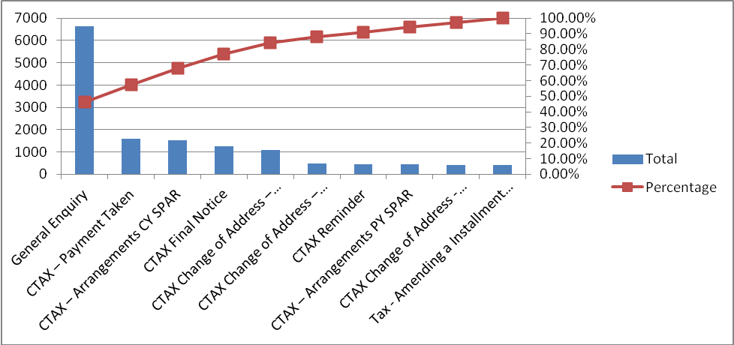

Benefits – Top 11 Classifications

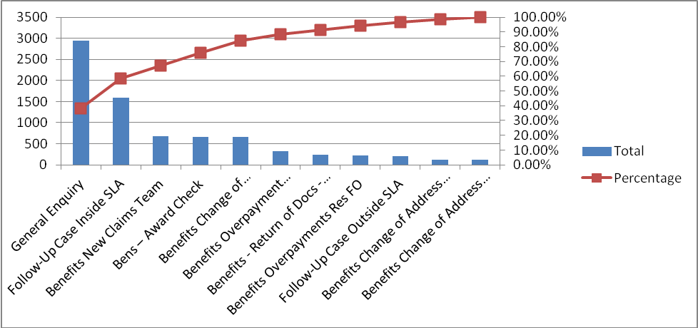
To fully understand how the current IVR can be changed, the following high use classifications will be investigated further to provide insight on any current trends:

Council Tax – Top 5 used Classifications

Subject | Reason | Type | Total | % | Cumulative %
Council Tax | Information and advice | General Enquiry | 6627 | 40.84% | 40.84%
Council Tax | Billing | CTAX – Payment Taken | 1600 | 9.86% | 50.70%
Council Tax | Reminder/ Final Notices | CTAX – Arrangements CY SPAR | 1508 | 9.29% | 59.99%
Council Tax | Reminder/ Final Notices | CTAX Final Notice | 1250 | 7.70% | 67.70%
Council Tax | Change of Address | CTAX Change of Address – Out of Borough | 1086 | 6.69% | 74.39%

Benefits – Top 5 used Classifications

Subject | Reason | Type | Total | % | Cumulative %
Benefits | Information And Advice | General Enquiry | 2952 | 36.66% | 36.66%
Benefits | New Claim/Change | Follow-Up Case Inside SLA | 1592 | 19.77% | 56.43%
Benefits | Benefits New Claims | Benefits New Claims Team | 675 | 8.38% | 64.81%
Benefits | Benefits Request for Information | Bens – Award Check | 667 | 8.28% | 73.09%
Benefits | Benefits Change of Circumstance | Benefits Change of Circumstance | 661 | 8.21% | 81.30%

Call Volumes

The figures below are for 01/06/2014 – 31/12/2014:

Queue |  | Jun-14 | Jul-14 | Aug-14 | Sep-14 | Oct-14 | Nov-14 | Dec-14 | Totals
Council Tax | Calls | 9585 | 9849 | 8791 | 10038 | 11039 | 9368 | 7686 | 117467
Council Tax | % of calls Classified | 9.23% | 9.97% | 11.64% | 17.40% | 18.88% | 45.29% | 64.51% | 23.99%
Housing Benefits | Calls | 9819 | 10695 | 8882 | 11132 | 10519 | 8439 | 8383 | 116047
Housing Benefits | % of calls Classified | 3.70% | 4.24% | 7.00% | 11.85% | 9.02% | 25.36% | 26.32% | 11.86%

Upon comparison of the calls and classifications in LAGAN we can see that 23.99% (15922 of 66356) of Council Tax calls received have been logged into LAGAN and 11.86% (8052 of 67869) of Benefit calls. While this cannot be taken as a definitive data set, it does illustrate a representative sample of the actions taken by Revenues and Benefit Advisors. As you can see from when we did an audit in September and stressed the importance of logging cases in Lagan there has been an increase in calls being classified although there is still massive scope for improvement in this area.

Note: A quick win is to present this data to the ACM for the team to reinforce the importance of classification as there should be one for every single call received by the team.

Investigation Into Specific Areas within Council Tax
The General Enquiry classification was the most frequently used classification of all the others with 40.84% of the calls classified being this type. From discussing with the manager of the service I have found that the following call types would justify the use of this classification.

- Banding Enquiries
- Copy Bill Request
- Next Payment queries
- Postal address enquiries
- Email address enquiries

There is also an issue with staff behaviour where they are using the General Enquiries classification as an easy route to classifying the call. This has been addressed and steps are now in place to review this. The classification was only created late October so I have taken October’s figures out of the graph.

On average 3150 calls were classified using General Enquiry each month

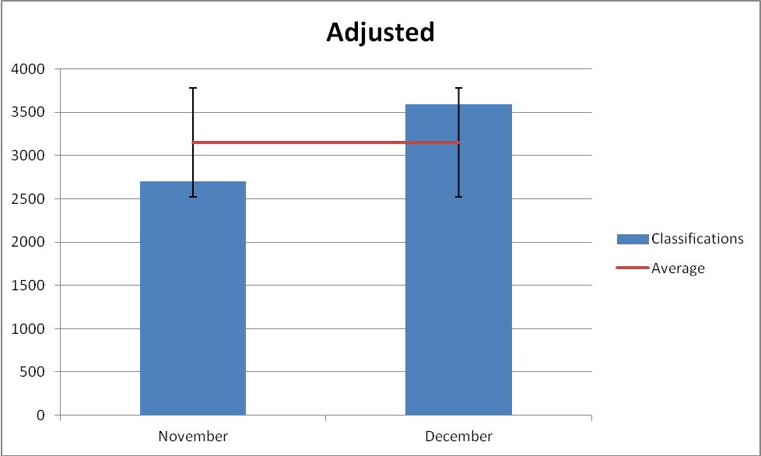

CTAX – Payment Taken – 9.86%of calls
The Council Tax>Billing>CTAX – Payment Taken classification is used by agents when a resident makes a payment.

This classification is used for when a customer calls up to make a payment for their Council Tax.

Utilising the data from June to December 2014:

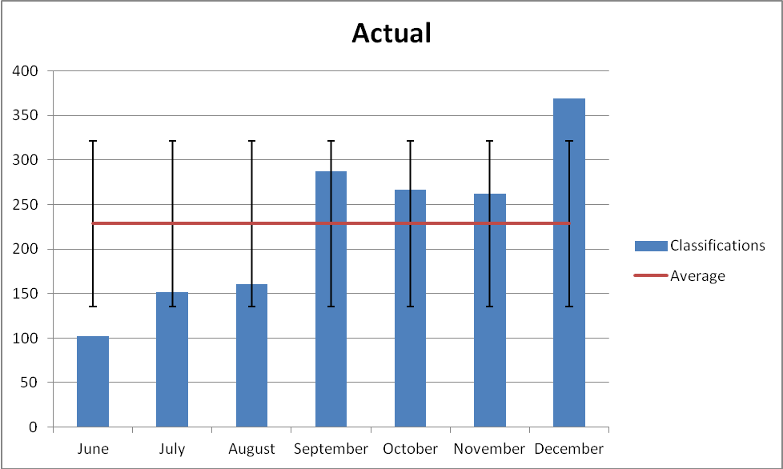

As you can see there is a big rise in the amount of payments taken from September onwards. This could be due to a number of reasons firstly the recovery run in September was a lot larger than those before with 4000 Summons and 1500 reminders being sent out. This would have caused an influx of payment calls to the contact centre. Also a backlog of work in the Back Office during July and August may have stalled people making their payments if waiting on adjusted statements.

Excluding June where a much smaller volume of payments were taken the average number of Payments classified monthly is 249.66.

CTAX - Arrangements CY SPAR – 9.29%of calls

The Council Tax>Reminder/Final Notices>CTAX – Arrangements CY SPAR classification is used by agents that have dealt with a Summons or 14 Day query and have had a Special Arrangement setup on their account.

Again the large recovery hit experienced in September may go some way to explaining the large rise of cases raised from September & October.

The chart below shows this standard distribution of these classification types from June to December 2014:

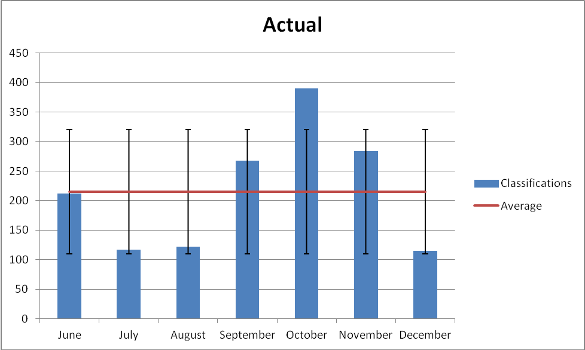

On average we classify 215.43 Special arrangement calls per month

CTAX Final Notice – 7.70%of calls

The Council Tax>Reminder/Final Notices>CTAX Final Notice classification is used by agents when they have dealt with a final Notice enquiry.
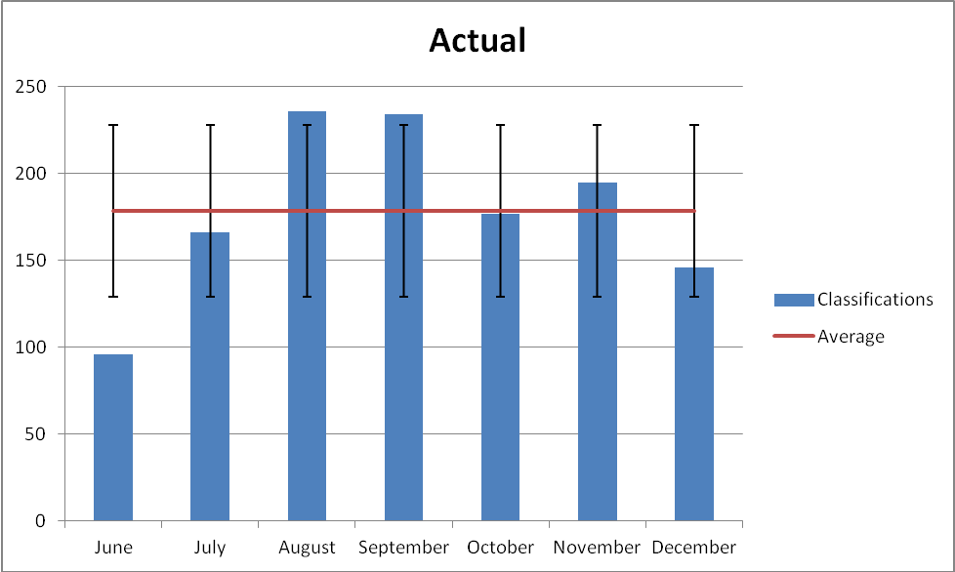

As you can see from the graph there was a drop in cases raised as ‘Final Notice’ in June. This is most likely down to the fact that the team only started using lagan in June and has missed the Final Notice hit that took place earlier on that month.

Upon reviewing the figures for June to December 2014:

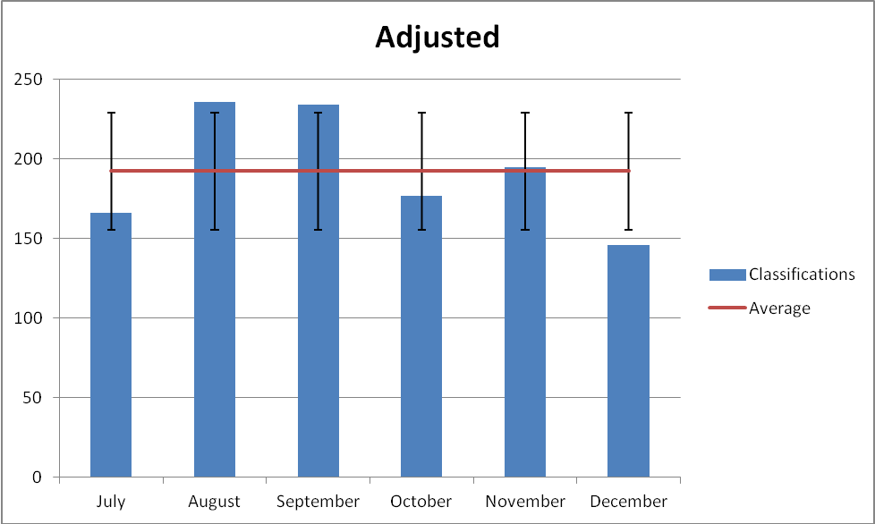

Now June has been taken out of the equation we are able to get a better flavour of the average monthly classifications for this type. On average 192.33 Final Notice classifications are raised.

CTAX Change of Address (Out) – 6.69%of calls

The Council Tax>Change of Address>CTAX Change of Address – Out of Borough is used when the advisor has processed a move out of the borough.

There was a raise in September for Moves out of the borough which seems to fit in with a seasonal pattern. Student’s moving because of College/University, Parents moving to be nearer to Children.

Again I have taken out June due to the late start using lagan that month as it will distort the monthly average.

As you can see on the below adjusted graph the monthly average for this call type is 171.16

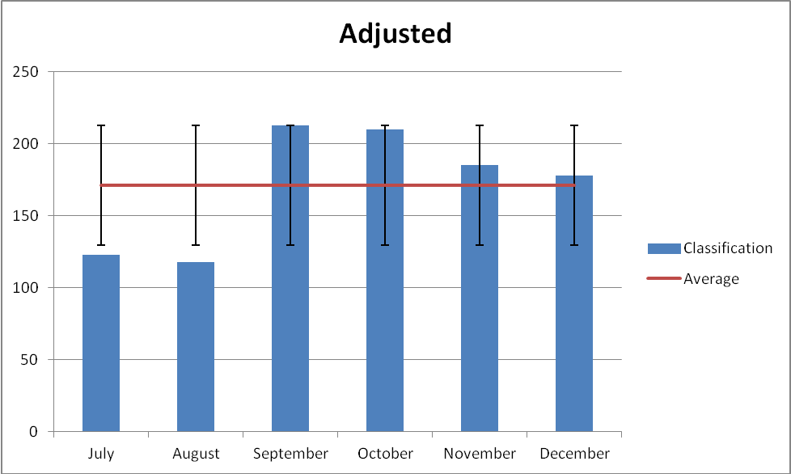

Investigation Into Specific Areas within Benefits
The General Enquiry classification was the most frequently used classification of all the others with 36.66% of the calls classified being this type. From discussing with the manager of the service I have found that the following call types would justify the use of this classification.

- Querying which offices they can hand documents in to
- Next Payment date
- Checking if we have received their documents
- Postal address enquiries
- Email address enquiries

There is also an issue with staff behaviour where they are using the General Enquiries classification as an easy route to classifying the call. This has been addressed and steps are now in place to review this. The classification was only created late October so I have taken October’s figures out of the graph.

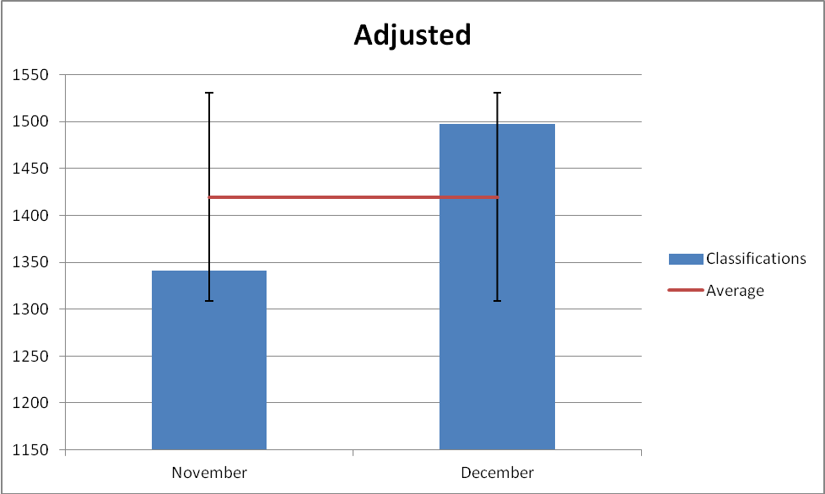

On average 1419.50 calls were classified using General Enquiry each month

Follow-Up Case Inside SLA – 19.77% of calls

The Benefits>New Claim/Change>Follow Up Case Inside SLA classification is used when an advisor takes a call from a resident who is chasing any of the following within its SLA
- Chasing update from proof they have sent in.
- Chasing update on a claim
- Chasing any outstanding document on the system

The classification was only setup in September so we only have records from then on. This has been reflected in the below graph.

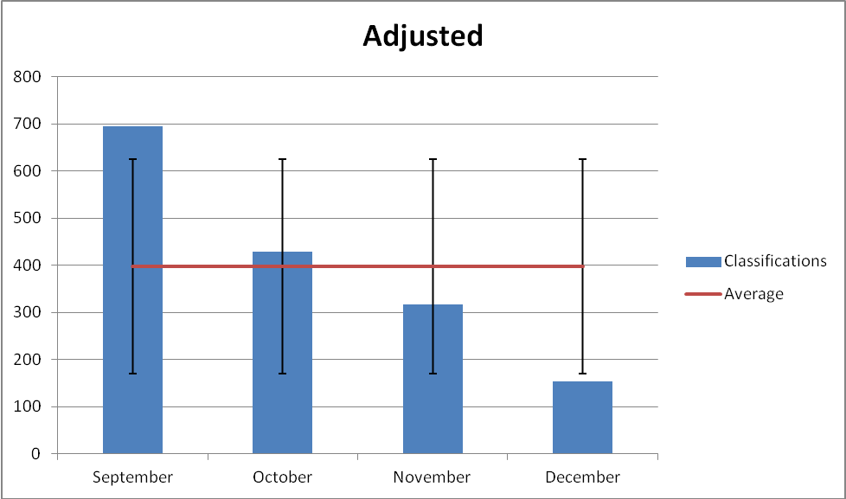
The fact Septembers figures are a lot higher than the rest of the year could be due to the backlog Back Office were experiencing which only started to clear in July. After liasing with the services contract manager they have advised of an issue where staff were classifying calls as follow up within SLA where they should have selected outsde of SLA. This has now been highlighted to staff and the scriptflow now forces them to classify the calls correctly.

The average monthly usage count for this classification is 398.

Benefits New Claims Team – 8.38% of calls

The Benefits>New Claim/Change>Benefits New Claims Team classification is used when a caller calls wanting to book an appointment to get assessed for benefits.

Also the jump in New Claims classifications in December coincides with the extra staffing that was put onto the New Claims line from other teams to support.

The graph below reflects all classifications between June – December 2014

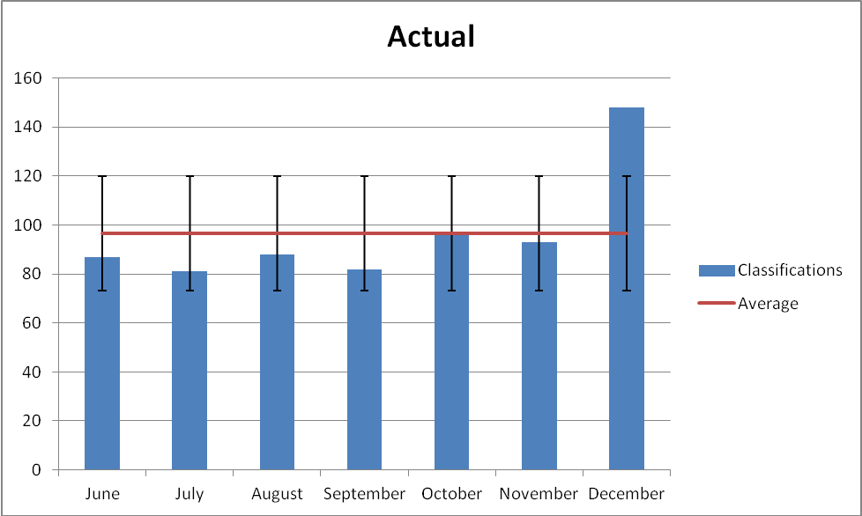

This equals a monthly average hit rate for this calssification of 96.43

Bens – Award Check – 8.28% of calls

The Benefits>Benefits Request for Information>Bens – Award Check classification is used for callers calling to check their benefit award or have queries relating to their benefit award.

The chart below shows this standard distribution of these classification types from June to December 2014:

Again the back log which back office started getting back on top of in July could have gone some way to explaining the rise in award check enquiries experienced in the months of July – September.

The drop in October coincides with a period of system issue’s and Staff shortage. We had 3 advisors leave in October and were experiencing really slow system speeds. The issue was resolved within a couple of days but there were niggling issues where Lagan kept freezing.
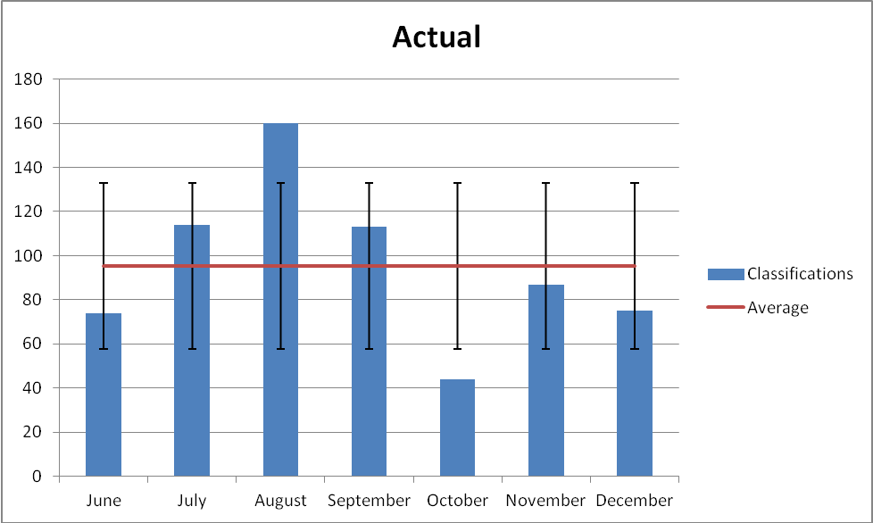

On average this classification is used 95.29 times.

Benefits Change of Circumstance – 8.21% of calls

The Benefits>Benefits Change of Circumstance> Benefits Change of Circumstance classification is used when a caller has reported a change in circumstance. This could be due to change to people in household, change in income, change in working hours etc.

Again you will see a seasonal trend here as a higher number of Change in Circumstance enquiries hit us in September mainly due to change in peoples household make up due to people going off to university.

The chart below shows this standard distribution of these classification types from June to December 2014:
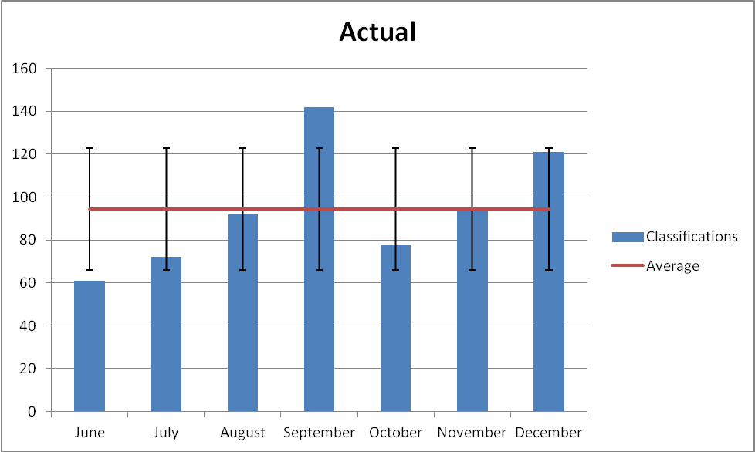

The average monthly usage of this classification is 94.43

Proposed IVR Changes

Revised IVR Flow

IVR website links analysis
Link | IVR Location | Functional
https://www.barnet.gov.uk/counciltax | Council Tax, Option 2 - Direct Debit | Would be better to offer an online form they can submit rather than having to download, fill out and send the form back in. this will then need processing at back office.  The Pay Council Tax online button at bottom of the page - link is not working (Page cannot be displayed).
https://www.barnet.gov.uk | Council Tax, Option 3 - Moves | Working fine.
https://www.barnet.gov.uk | Council Tax, Option 4.1 – Discount & Exemptions | Working fine.
https://www.barnet.gov.uk | Council Tax, Option 5 – Query Bill, Refund or Letter | Working fine.
https://www.barnet.gov.uk/benefits | Benefits, Option 1 – New Claim | Getting to the page is fine but the order in which the options are displayed to the customer need re jigging. Out of the 2 options available to make a new claim filling in the online form needs to be the first option (currently call the contact centre) then we can offer a phone number to call in as a second option.
https://www.barnet.gov.uk | Benefits, Option 2 – Change of Circumstance | Would be better to offer an online form they can submit rather than having to download, fill out and send the form back in. this will then need processing at back office.

Benefit Assumptions

Title | Description | Benefit | Assumptions
Promotion of Self Serve | Introduction of Self Serve signposting and advice messages | Enables callers to deal with enquiries interactively rather than through an agent, bringing volume of calls to agents down. | Callers are willing and able to self serve. CAS to protect those that aren’t able
OOH Facility | A facility for callers to speak to a virtual advisor (pre recorded messages) 24 hours a day. | This should bring down agent contact volume. | Callers are willing and able to use this service. CAS to protect those that aren’t able
Reporting | Introduction of separate skills for Revenues and Benefits | More visibility of incoming calls and the subsequent output via management information. | New skills added to existing staff. MI reports amended with new skills/VDN's.
My Account | Advising residents to use the My Account portal | Quicker streamlined process through My Account. Again reducing agent contact volume. | My Account is promoted and residents take up the option.
Whispers | Introduction of whispers so agents are able to mentally prepare for the call. | This should reduce AHT as advisor can ask specific query related questions. | The whisper plays and is clear.
Bite Size Training | We would be able to have partially trained staff on phones taking calls | Staff can help take calls when they have only received bite size training. This would make the transition of ''off the street'' to ''on the phone'' a lot quicker for in demand contracts. We have also been able to introduce Global Skilled Advisors to take the appointment calls | The product supports bite size training.
Queue Management | Split Skills for each service. | Queue managers will be able to micro manage the service due to having more flexibility with split skills. Forecasting & Planning can also be done with more accuracy as specific lines can be covered | New skills added to Queue and Planning tools.
Percentages of call distribution | The percentage breakdown of calls is based on classifications raised | We are able to get a flavour of the volumes we are expected to see through each channel. Now with the extra IVR options it should go some way to reducing the amount of General Enquiries raised. | Advisors are classifying calls correctly.

