**Commissioning Group**

The Group consists of two teams; commissioning strategy, who develop and implement commissioning strategies for a broad set of community-related areas including public health, children and young people, community wellbeing, regeneration and environment; and commissioning resources are responsible for the retained functions which support the council’s operations including HR and finance, communications, information management, programmes, performance and commercial functions. The teams work together to deliver the Corporate Plan, six committee Commissioning Plans and Financial Strategy to save £81m up to 2020.

Commissioning Group identifies and develops the business cases and delivery specifications required to deliver the plans and priorities set out above by embedding them as part of the Council’s change programme and annual budgets. Commissioning Group consists of creative and innovative employees who challenge established approaches, and lead and shape changes to meet our priority outcomes. Teams work together to assess the market and develop it where necessary, and involve users in design and delivery. The Commissioning Group’s commercial function are responsible for managing the council’s commercial contracts and work with Senior Responsible Offers to ensure that the Council continues to receive a good quality service as specified in the CSG and Re contracts delivering £126m and £39m, over ten years.

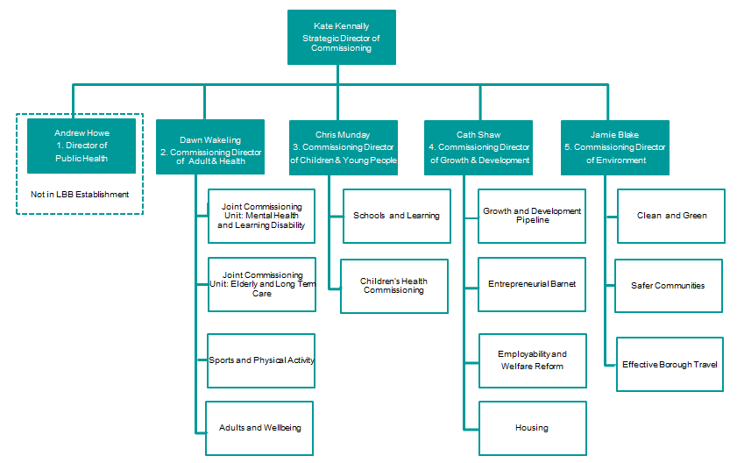

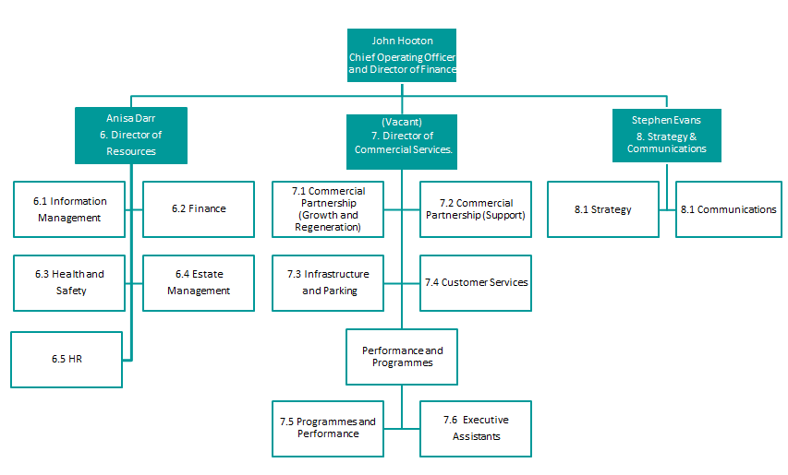

1. **Commissioning Public Health**

The Director of Public Health is Andrew Howe. The team is responsible for a range of statutory and non-statutory services focused around promoting healthy living amongst residents. Its statutory duties include overseeing the provision of genitourinary medicine and contraceptive services, health checks for young children, and Early Year’s health visiting and school nursing. Its non-statutory services include the provision of drug and alcohol related services, smoking cessation, mental health services, and promoting self-care and Sports and Physical Activity. Public Health is a shared service between Barnet Council and Harrow Council, it is housed within Harrow.

1. **Commissioning Adults and Health**

The Commissioning Director for Adults and Health is Dawn Wakeling. The team is responsible for commissioning adult social care services from the Adults and Communities Delivery Unit. The team includes well-being and transformation (led by Courtney Davis and Kirstie Haines) who are leading on developing strategies and policies that encourage independence, promote self-management and prevention, reduce demand and re-shape the housing offer for adults in social care. The Sports and Physical Activity (SPA) Programme is also overseen by Cassie Bridger. The team works closely with Health and Wellbeing Being Board (HWBB) to produce the Health and Well-being Strategy).

The Joint Commissioning Unit (JCU) is led by Rodney D’Costa and is also within the Adults and Health commissioning team. The team works to ensure high standards in the care market and ensure partner organisations and private sector providers work towards the council’s strategic objectives. These include promoting independence, prevention and a range of initiatives to redesign service. One of the ways they achieve this is by intervening in the market for adult social care. The team has the further responsibility of overseeing the council’s new Prevention and Well-Being Duty Set out in the Care Act. This includes providing information, giving advice and building community infrastructure, working closely with carers and the wider voluntary sector. They work closely with the Clinical Commissioning Group (CCG), Barnet Enfield and Haringey Mental Health Trust (BEHMHT) and the Central London Community Healthcare (CLCH) NHS Trust on Learning Disability services.

1. **Commissioning Children and Young People**

The team commissions a range of children’s education and social care services. The Commissioning Director for Children & Young People is Chris Munday. Chris Munday is the council’s Director of Children’s Services (DCS). He is responsible for ensuring that effective safeguarding and social care management assurance is in place. The team is overseeing the establishment of an integrated service for children and young people with disabilities (0-25) and implementing the Children and Families Act. They commission a range of services that aim to reduce child poverty, bring together organisations involved in child safeguarding and improve community safety. The team also commissions a range of new integrated health services.

Val White is overseeing the project to deliver an alternative delivery model for Education and Skills, the transformation of the libraries service, including engaging with members and the local community and encouraging innovation, and the Education Capital Programme.

1. **Commissioning Growth and Development**

Cath Shaw is the Commissioning Director for Growth and Development. This team is responsible for housing, planning and regeneration, managing a pipeline of new developments on council’ land, promoting economic growth within the council and ensuring residents have support available to get into work. Growth and Development is also responsible for formulating the council’s response to welfare reform and planning and implementing the council’s Housing Strategy and managing the Housing Revenue Account (HRA) led by Paul Shipway. One of its key initiatives is ‘Entrepreneurial Barnet’, which aims to make Barnet the best place in London to be a small business, making business growth a core priority of the council.

1. **Commissioning Director Environment**

Jamie Blake is the Commissioning Director for Environment, The team is responsible for working to enhance Barnet’s environment through effective regulation, and management and stewardship of the council’s infrastructure and green spaces. They are responsible for commissioning Parks & Open Spaces and Street Scene to ensure Barnet’s streets, parks and open spaces are well maintained. They work closely with the North London Waste Authority and West London Alliance.

The Effective Borough Travel team is responsible overseeing the development of highways and public transport strategy. This covers investment planning, maintaining highways, managing parking and linking local investment to investment at a city wide and nationwide level.

The Community Safety Team is led by Kiran Vagarwal. The team works closely with the police and wider Community Safety partners to ensure that Barnet remains a place where people feel safe. This includes maintaining links between Community Safety, Environmental Health and Domestic Violence services. The team also plays a key role in adult safeguarding, CCTV operation and liaising with housing to make troubled neighbourhoods safer.

1. **Resources**

6.1 Information management

The Information Management (IM) team is led by Head of Information Management, Jenny Obee. The team’s role is to ensure effective management, use and security of information. The IM team are responsible for implementing the council’s Information Management strategy; compliance with Freedom of Information requests and Data Protection Acts; promoting transparency through the Open Barnet open data portal; and managing off site archives. The team is also responsible for monitoring the council’s response to complaints and manages the council’s IT contract with the Customer Support Group (CSG).

The Emergency Planning Team supports the Emergency Services to reduce the impact of emergencies. This includes assessing the risk of a particular emergency occurring, putting plans in place to ensure that the Borough has the capacity to respond effectively, and putting in place arrangements to provide the public with information and advice. The team are also responsible for the effective delivery of Business Continuity across the Council.

6.2 Finance

The role of Head of Finance is vacant. The Finance Team manages business planning and financial strategy for the council. The Senior Responsible Officer (SRO) for the CSG finance service is within Commissioning Group and ensures that the council continue to receive a good quality service as specified in the contract.

Jonathon Wooldridge is the Revenue and Benefits Manager. The Revenue and Benefits SRO also sits within finance and is responsible for monitoring the Customer Support Group’s work in relation to revenues and benefits to ensure they provide a good service. Revenues and Benefits service is responsible for overseeing the collection of Council Tax and Business Rates also pays out Housing Benefit and Council Tax support, and designs and implements local support schemes for unemployed and low paid residents.

Paul Lawrence is the Head of Insurance. The Insurance Team manages the council’s insurance portfolio, protecting council assets and handling all claims made against them. This includes cases in which residents allege that the council’s service delivery has been negligent. The team provides advice on insurance and on the indemnity requirements of all contracts. They also advise directors, service managers, budget holders and relevant partners on operational insurance and risk management.

6.3Health and Safety

Michael Koumi is the Head of Safety, Health and Wellbeing. He is the council’s ‘Statutory Health and Safety Competent Person’, meaning that he monitors the council’s Health and Safety performance and advises the organisation on corporate health and safety risk and mitigation. He sets the council’s corporate Health and Safety, and workforce wellbeing, policies and strategies, advises on strategic health and safety implications for commissions, and leads on consultation with the Delivery Units on health and safety matters. He is also the Senior Responsible Officer for the Health and Safety, Occupational Health and Employee Assistance services provided by CSG.

6.4 Estates

Chris Smith is the Head of Estates Management. Estates are responsible for development of LBB estate strategies and managing the relationship with Customer Support Group (CSG) and Re for work relating to estates, which includes facilities management, property management, building services, building security and print services. Chris is also. the LBB client for all capital works.

6.5 HR

Liz Hammond (interim) is the lead HR Consultant. Her role is to monitor the HR contract with Capita ensuring that they provide the council with a high quality service.

1. **Commercial**

7.1 and 7.2 Commercial Partnership Team

The Commercial Partnership Teams are led by Helen Bailey and Philip Hamberger. They are responsible for managing the council’s commercial contracts. These include:

* Barnet Homes
* The Customer Support Group (CSG)
* GDIT
* Harrow and Barnet Public Health
* Harrow and Barnet Public Law
* The Mortuary Service
* Re
* Registrars

More information about these partnerships is included on page 9.

7.3 Parking and Infrastructure

Paul Bragg is the Parking and Infrastructure Manager. His teams are responsible for parking, street lighting and highways. The Parking Client Team is responsible for monitoring the performance of a range of private sector contracts that relate to parking and handling disputes. The Street Lighting PFI Contract Client Team manages the performance of the contracts relating to street lighting, electricity and Wi-Fi. The Highways Direct Labour Organisation (DLO) is responsible for reactive highway maintenance and gritting. The Highways Sign Shop is responsible for manufacturing and installing signs.

7.4 Customer Services

Kari Manovitch is Head of Customer Strategy and Programmes. She is responsible for leading the development and implementation of the Customer Access Strategy (CAS) and promoting ‘digital by default’. She works to ensure an excellent customer experience across all council services and access methods, upholding the council’s customer care commitments, and encouraging all staff to ‘think customer’. She manages the council’s customer services providers including the Customer Support Group (CSG), overseeing performance improvement and transformation. She is the Proper Officer for Registration and Nationalities, meaning that she manages the client relationship with Brent to provide registrar services.

7.5-7.6 The Strategic Lead for Performance and Programmes is Tom Pike who oversees Programmes and Resources, Performance and Executive Assistant teams.

7.5 Performance and Programmes

The Programmes Team is led by Jamie Masraff (interim). The team’s three main roles are to: provide strategic advice and support on projects, advising on how best to set-up, design and deliver projects, as well as on resourcing, project controls and governance; provide project assurance activities (which includes review of project progress, delivery of benefits and ensuring the council is getting value for money) and assistance with implementing gateway reviews; and the team are responsible for contract management of CSG Corporate Programmes. This includes brokering project resource and specialist advice from CSG, reviewing and challenging CSG managed projects and client side management of the CSG Project Management Office (PMO) (which provides portfolio reporting, support and light touch assurance to projects).

The Performance Team is led by Alaine Clarke. The team is responsible for supporting commissioners and Delivery Units with performance improvement. It coordinates production of the Council’s key business plans and Management Agreements. It assures efficient delivery of the Corporate Plan (and other key business plans) through monitoring, review and challenge. It undertakes regular reporting of performance data to Delivery Unit Board, Strategic Commissioning Board and Performance & Contract Management Committee.

7.6 Executive Assistants Team

The Executive Assistants Team support senior officers within the Commissioning Group with their day to day activities. This includes the Chief Executive, the Leader of the council, the Strategic Director of Commissioning, the Chief Operating Officer, the Assurance Director and the Commissioning Directors. They also support a range of management and resource enabling boards. These include: the Strategic Commissioning Board, the Delivery Unit Board, the Commissioning Group Management Team, the Assets and Capital Board and the Workforce Board.

1. **Strategy and Communications**

8.1 Communications

The Head of Communications is Katie Mayers. The team's role is to promote the council and protect its reputation, dealing with all proactive and reactive media relations, planning external and internal communications campaigns, running consultations with residents and staff, and ensuring that all staff are kept up to date with change and transformation plans. It also manages the council's corporate website, and includes the council's in-house design team which carries out design work for internal and external campaigns.

8.2 Strategy

The Strategy Team reports directly to Stephen Evans. It covers four main areas: strategic planning, business intelligence, equalities and community engagement. The strategic planning function involves developing communications strategy, corporate planning and organising campaigns. As part of promoting community engagement, the team supports local communities to take on greater responsibility for local services. The Equalities Officer works to build equalities assessment into day to day council business and business planning. The Business Intelligence Officer works to ensure the council has access to comprehensive up to date information about the borough. This includes targeting the Insight Team within the Customer Support Group (CSG) to ensure they work towards the priorities of the Corporate Plan.

# Partner organisations

* Barnet Homes- the council’s arm’s length management organisation that manages the council’s housing stock
* Community Barnet- an organisation that coordinates the voluntary and community sector within Barnet
* The Customer Support Group (CSG)- the partnership with Capita that runs our back office services as well as supporting transformation
* General Dynamics Information Technology (GDIT)- the service that provides our Out of Hours call handling
* Harrow and Barnet Public Health- a shared service with Harrow Council
* Harrow and Barnet public law- also a shared service with Harrow
* The Mortuary Service
* Regional Enterprise (Re)- our joint venture with Capita to deliver development and regulatory services in the borough
* Registrars- a shared service with Brent Council