**Strong Women in Literature**

**Good reads for International Women’s Day**

**Strong female characters**

 Mary Lennox – *The Secret Garden* by Frances Hodgson Burnett (1911)

A sour and disagreeable young orphan is relocated from India to Misslethwaite manor. Here she discovers a walled, apparently dead garden. She revives not only the garden and her sickly cousin but also herself. A positive tale where hope and strength win over neglect and sadness.

 Scout Finch – *To Kill a Mockingbird* by Harper Lee (1960)

An intelligent, sensitive tomboy, Scout’s childish temper and mischievousness are replaced by tolerance and understanding as she absorbs the world beyond childhood.

 Elizabeth Bennet – *Pride and Prejudice* by Jane Austen (1813)

Lively and high-spirited, Elizabeth is pained by the crassness of her mother and younger sisters. Attractive, honest and outgoing she draws the attention of Mr Darcy. Believing him proud and arrogant she rejects his first proposal of marriage. However, on uncovering his true nature she reconsiders her initial prejudice.

 Jane Eyre – *Jane Eyre* by Charlotte Bronte (1847)

Plain but passionate, orphan Jane endures a cruel and loveless upbringing. Her optimism and fighting spirit help her secure a governess position at Thornfield Hall. She refuses to cede to the passion she feels for the master of the house, Mr Rochester. She flees but returns once she understands and conquers her emotions.

 Coraline – Coraline by Neil Gaiman (2002)

Eerie novel, where Coraline discovers a passage to an alternate, mirror universe. While the other world is in many ways better than the original, Coraline eventually realizes that all is not as it seems and that she must rescue the children's souls that are trapped there, along with herself.

Find out more: [www.barnet.gov.uk/libraries](http://www.barnet.gov.uk/libraries)

* barnetlibraries
* @barnetlibraries

**Strong Women in Literature**

**Good reads for International Women’s Day**

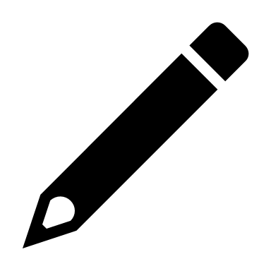 **Strong female authors**

 Maya Angelou, 1928-2014

African American author, poet, and playwright. Best known for *I Know Why the Caged Bird Sings*, the first in a series of Angelou’s autobiographical works. Her poetry has been praised for discussing social and political issues important to African Americans. Angelou has received numerous awards for her work.

 Simone de Beauvoir, 1908-1986

Simone de Beauvoir was one of the most influential feminist thinkers of the 20th century. A novelist, political activist, memoirist and philosopher, she is best known for ‘The Second Sex’ which was revolutionary in its discussions on the role of women in society. On her death, feminist writer Gloria Steinem proclaimed that “if any single human being can be credited with inspiring the current international women’s movement, it’s Simone de Beauvoir.”

 Chimamanda Ngozi Adichie, 1977-

Chimamanda grew up in Nigeria. Her novels include *Purple Hibiscus*, *Half of a Yellow Sun* which won the Orange Prize and *Americanah*. Her non-fiction book *We Should all be Feminists* started a worldwide conversation about feminism.

 Zadie Smith, 1975-

Born in Northwest London, Zadie Smith is the author of *Swing Time,* *White Teeth, The Autograph Man, On Beauty, Changing My Mind*, and*NW.*Her booksdeal with issues of race, postcolonial identity, and class tensions.

 Caitlin Moran, 1975-

Catherine Elizabeth "Caitlin" Moran **i**s the author of *How to be a Woman* and *How* *To Build a Girl*. She was named one of Britain's most influential women in the BBC *Woman's Hour* power list 2014.

Find out more: [www.barnet.gov.uk/libraries](http://www.barnet.gov.uk/libraries)

* barnetlibraries
* @barnetlibraries