Edible Books
Celebrity judge,
Richard Burr
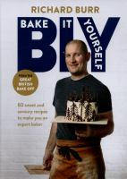
Great British Bake
Off finalist, 2014
Osidge Library, Saturday 20 February, 2.00pm-3.30pm
Bring along an edible book to be in with a chance of winning this family friendly competition. Your book-themed creation can be a cake,
or anything else as long as it is edible!
Pick up the entry rules from Osidge library or check the website.
Children and adult entries welcome. Register by noon on 19 February.
For enquiries and registration details contact:
Osidge Library, Brunswick Park Road, London N11 1EY Tel. 020 8359 3920

