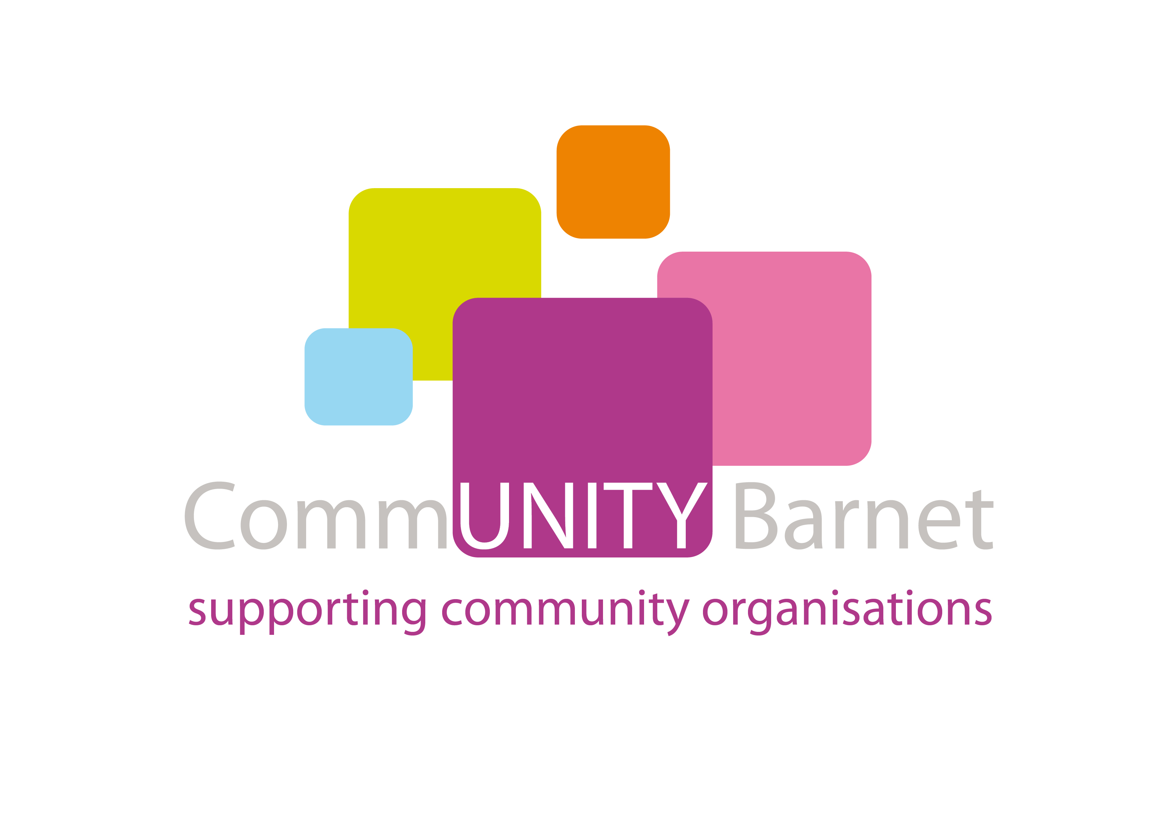

Barnet Action on Neglect Conference

Wednesday, 13 March 2013

DATE: Wednesday, 13 March 2013

TIME: 9.30 -1pm (Half day)

WHO SHOULD ATTEND: The children and young people’s workforce – anyone who works with children and young people in Barnet across all the services and agencies (health, social care and education, working in the statutory, voluntary, and private sectors). This event also welcomes colleagues from the Children’s Improvement Board, Munro Development Demonstrator programme.

FAX-BACK BOOKING FORM

To reserve your place at the above event please complete your contact details below and email or fax this form back to:

childrens.workforce@barnet.gov.uk or FAX NO. 0870 889 7445

CONFIRMATION
I would like to confirm my attendance at the briefing event for the children’s services workforce in Barnet.

Name: ………………………………………………………………………………..

Position/Job title:…………………………………………………………………..

Organisation: ……………………………………………………………………….

Day-time phone number: …………………………………………………………

email address: ……………………………………………………………………...

Please state your preferred event: ……………………………………………..

Special dietary requirements (please state): …………………………………

Service Area (please circle as appropriate): Health, Social Care, Education, Early Years, Other (please state)……………………………………………….

Additional requirements: If you have any special requirements please describe them be
…………………………………………………………………………………………

Please copy and complete the form for any additional persons you wish to attend.

