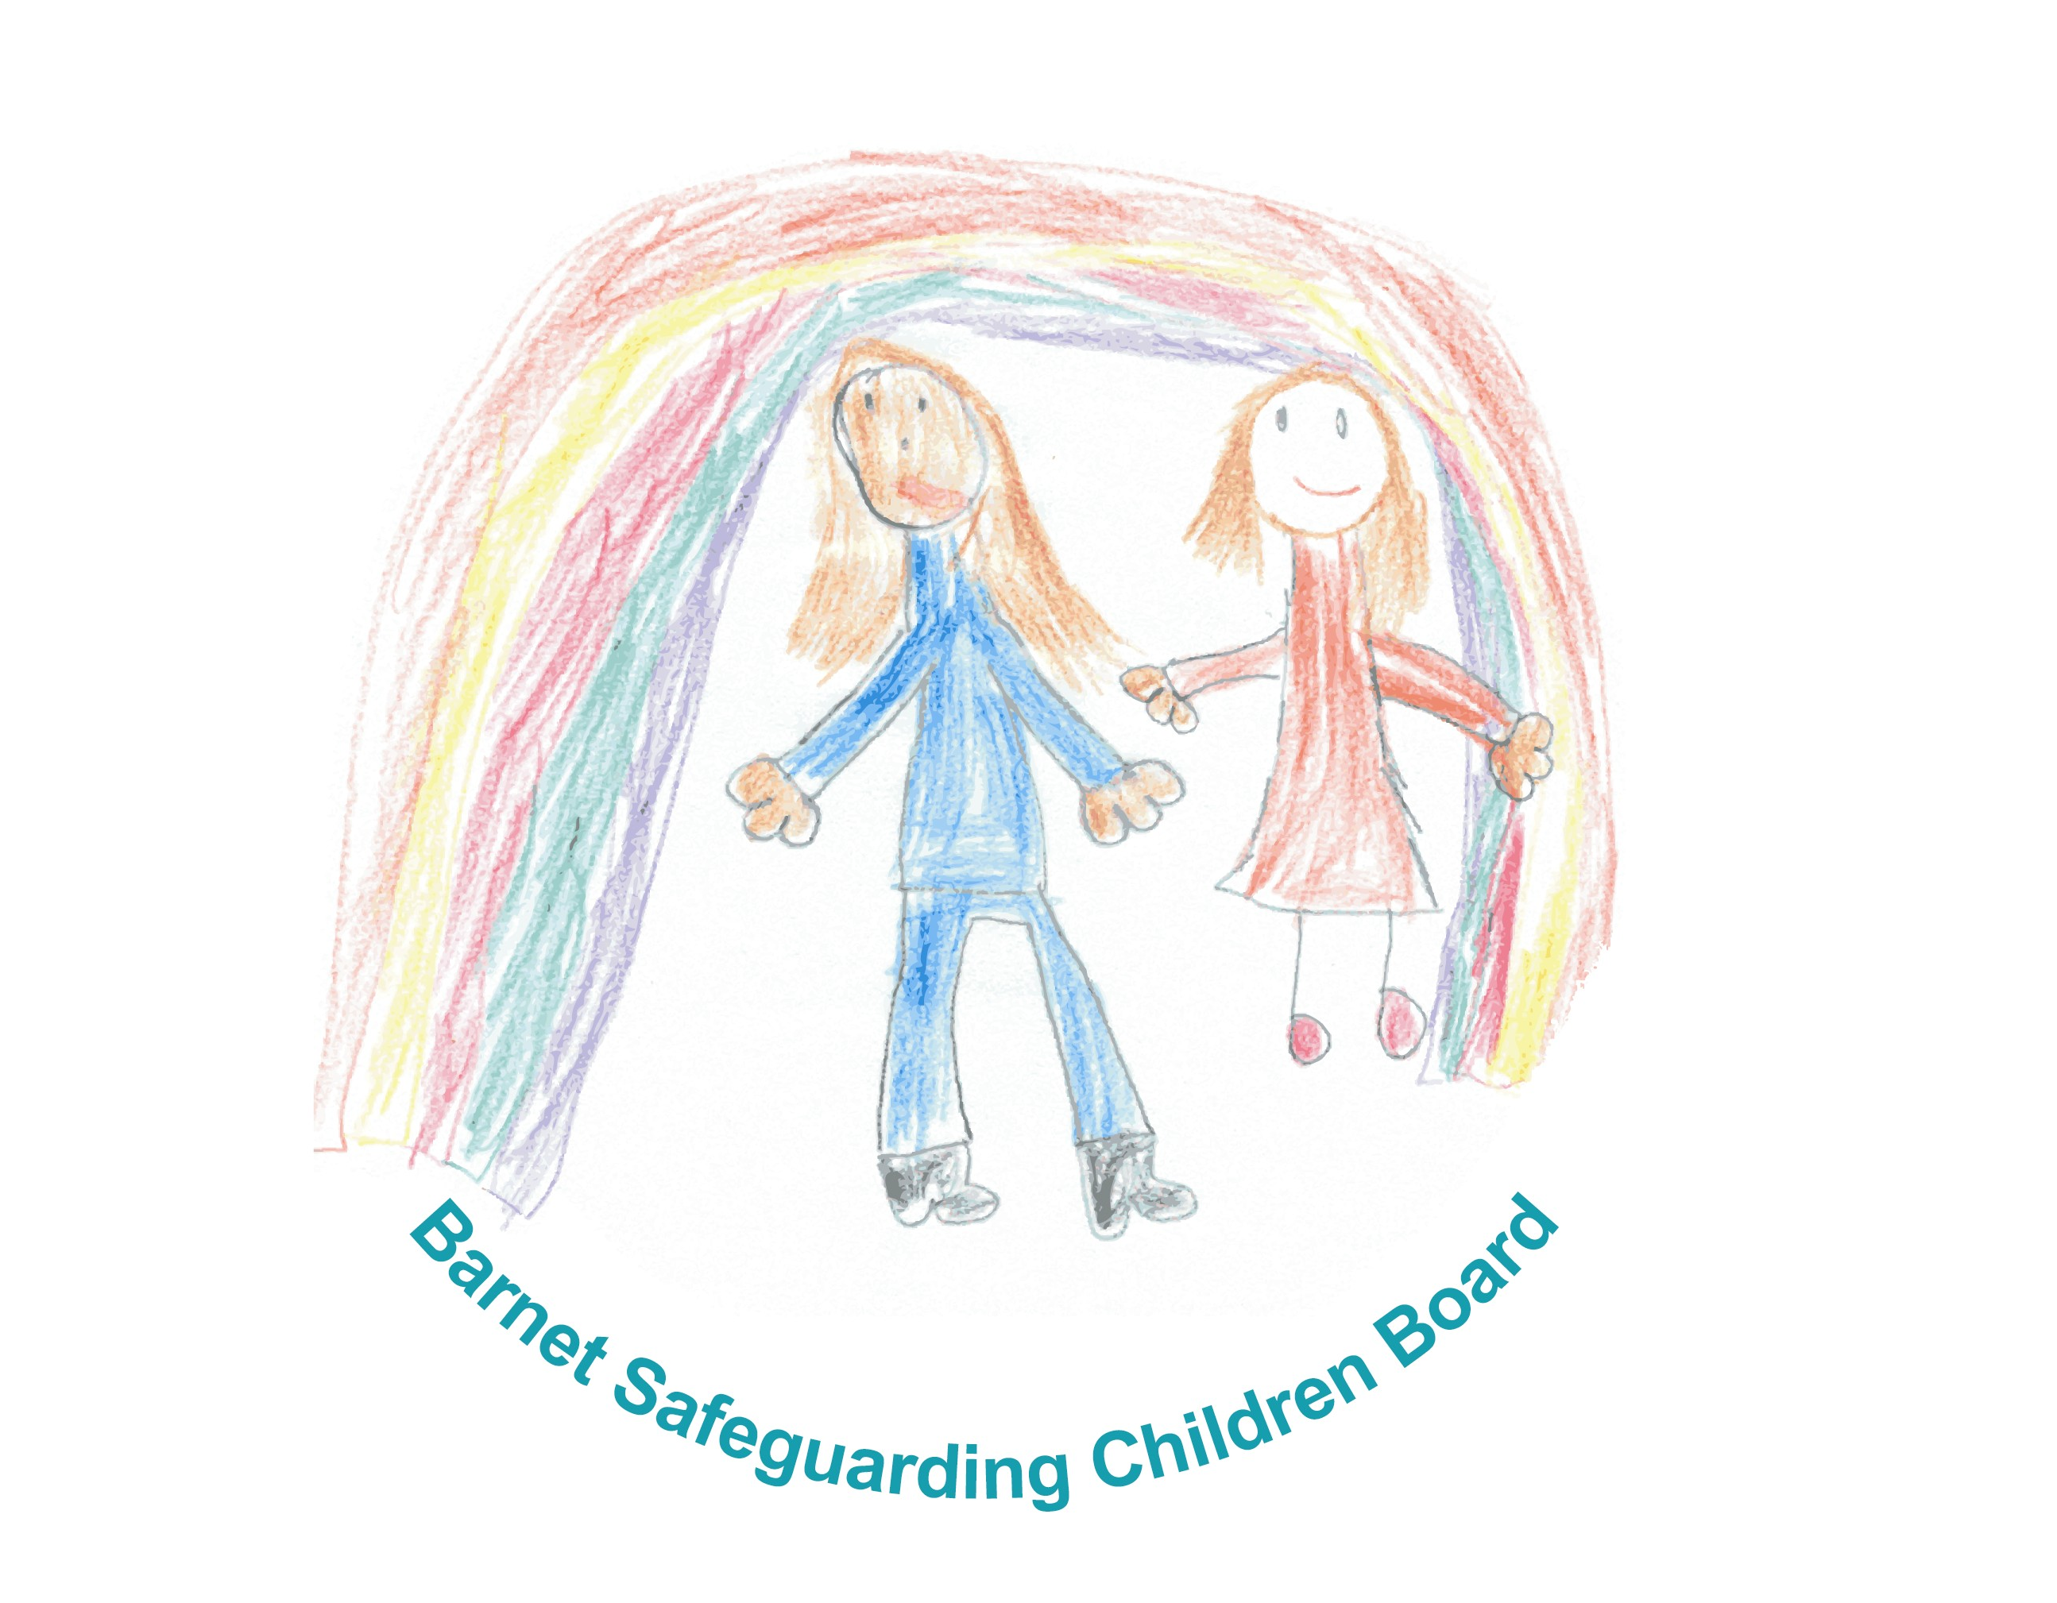

Guidelines for Safe Use of Digital Technology in Child Care Settings

Contents

Introduction

Related Guidance

Good Practice for Staff and Volunteers
- Photography and videos
- Access to inappropriate images and internet use
- Communication with children through technology

Data Protection

Responding to Concerns

Contacts and Further Resources

Appendices

- Acceptable Use Policy

- Acceptable Use Agreement

- Acceptable Use Agreement for Photos

- Photograph/Video Permission

Introduction

This guidance has been produced for childcare and early year’s settings, including nurseries, pre-schools, childminders and out of school clubs and complements the broader Education e safety Policy Guidance that is available on the London Grid for Learning Resources page. It is intended to give practical advice to staff and volunteers in safeguarding children from the risks associated with digital technology as well as ensuring that staff protect themselves through safe and responsible working practices. This guidance should be made available to parents and carers and should be regularly updated. The guidance includes acceptable use policies and agreements as well as photography and video permission.

New technologies open up many exciting benefits and opportunities for learning and development but can also present risks. Wider access to technology via mobile phones, games consoles and other devices bring new challenges about controlling access and content. The Barnet Safeguarding Children Board e safety strategy provides a detailed overview together with recommended strategies and resources for education providers, parents and children and young people.

Although children within Early Years Settings will not normally be accessing technology independently and benefit from a high level of supervision, there is always a small element of risk.

Safeguarding is everyone’s responsibility and all providers have a role in helping children stay safe on line and supporting the adults who work with children in minimising risks.

E safety responsibilities for providers include technological infrastructure, filtering and monitoring systems, recognition and responses to e safety concerns plus ongoing risk assessment to identify emerging issues

Safer Working Practice is essential as although most people who work with children have their best interests at heart, we know that sadly some people have abused their position of trust to abuse children in ways that have been further amplified through the digital environment. This should therefore be seen as part of the broader responsibilities that everyone working with children has to safeguard their welfare.

Related Guidance

This guidance forms part of a wider suite of child protection and safeguarding documents and the following in particular should also be referenced
- Barnet Safeguarding Children Board E Safety Strategy
- Child Protection Guidelines for Childminders, Early Years Settings and Out of School Clubs

Good Practice for Staff and Volunteers

Photography and Videos

ICT has an important role in supporting children's learning and development. For example, photographs of children engaged in a variety of activities and experiences can provide valuable evidence to include within learning journals.
To promote safer use of ICT, it is essential that when work with children involves the taking or recording of images this should safeguard the privacy, dignity and well being of children. Informed written consent, using a proforma such as the attached, should be obtained from parents or carers and agreement should also be sought from the child, where possible.
Care should be taken to ensure that all parties understand the implications especially if the image is to be used for any publicity purposes or published in the media. There should be agreement as to how the images will be stored, and for how long.
Adults need to be sensitive to children who appear uncomfortable and be alert to the potential for such activities to lead to misunderstandings.
It is not appropriate for adults to take photographs of children for their own personal use.

Helpful Hints

Do
- Be clear about the purpose of the activity and what will happen to the images
- Be able to justify images of children in your possession
- Avoid making images in one to one situations or that show a single child with no surrounding context
- Ensure the child understands why the images are being taken and that they are appropriately dressed
- Only use equipment provided or authorised by the organisation
- Report any concerns about inappropriate or intrusive images found
- Ensure you have parental permission to take and/or display photographs

Do Not
- Display or distribute images without consent
- Use images that could cause distress
- Use mobile phones or other devices to take photographs, (unless you have specific authorisation)
- Use personal ICT equipment, unless with specific authorisation
- Take images ‘in secret’ or images in situations that could be construed as being secretive

Access to Inappropriate Images and Internet Use

There are no circumstances that will justify adults possessing indecent images of children. Accessing, making and storing indecent images of children on the internet are illegal. Adults who are involved in this activity will be viewed as a threat to children and will be subject to a criminal investigation that if proven will result in them being barred from working with children.
Adults should not use equipment belonging to the setting to access pornography, nor should personal equipment containing such images be brought into the workplace.
Adults should ensure that children are not exposed to inappropriate images or web sites. Appropriate controls should be in place to prevent this, for example, through use of filters and personal passwords
Where indecent images are found, this must be reported immediately via the manager (unless the manager is the subject of the concern) who will alert the Police and/or the Local Authority Designated Officer (LADO).
Adults who discover such images should not attempt to investigate the matter themselves as this could compromise an investigation

Do
- Have policies in place about internet use for example through an acceptable use agreement
- Follow guidance on the use of IT equipment
- Ensure that children are not exposed to unsuitable material on line
- Ensure that any films or material shown to children and young people are age appropriate

Communication with Children through technology

Communication between children and adults should take place within clear and explicit professional boundaries. This includes the use of technology such as mobile phones, text messaging, websites etc. Adults should ensure that all communications are transparent and open to scrutiny. There is a need to be cautious to avoid any possible misinterpretation of motives or behaviour that could be interpreted as grooming. Adults should not therefore give personal contact details to children unless in exceptional circumstances the need to do so is agreed with managers and parents. E mail communications outside of the agreed protocols may lead to disciplinary action and e mail systems should be used in accordance with the acceptable use agreed policy.

Do

- Have an agreement about permissible and acceptable modes of communication
- Only use equipment provided by the setting to communicate with parents/children
- Only make contact with children for professional reasons and follow acceptable use agreement
- Be careful about your own use of technology and who has access, for example, social networking sites

Do Not

- Give out personal contact details to children or young people
- Use internet or web based communication channels to send personal messages to a child or young person

Data Protection

Data Protection means that all who hold personal data either on paper or electronically must keep it secure
Personal data is defined as any data that enables an individual to be identified including names, contact details, and so on.
Any item that can hold information requires controls to be put in place to prevent it being damaged or stolen. This will include CDs, DVDs and memory sticks.
All staff should be aware of the settings guidance regarding storage, transmission and removal to ensure data is kept safe.

Responding to Concerns

Any concern in a child care setting should in the first instance be reported to the Manager or Designated Safeguarding Officer, (unless they are the subject of concern) in which case seek advice from the Local Authority Designated Officer

The Manager will consider whether the concern needs to be referred to The Police and/or Children’s Social Care as a safeguarding incident. If the concern is about the behaviour of staff or volunteers then it should be reported to the Local Authority Designated Officer.

For further detail, please refer to your Child Protection Procedures

Childminders are themselves the designated safeguarding person so should seek advice directly from Children’s Social Care, Barnet Childminding Team and should inform Ofsted.

Ofsted also need to be notified as soon as reasonably practicable, but not later than 14 days after the event

Contact numbers are listed below

Barnet Children’s Service Consultation Line
( 9.30-11.30 Tuesday and Wed)
This number is available for consultation, advice or when you want to talk over a situation 020 8359 4336

Referral and Assessment Team (during office hours)
020 8359 4066/4097

Out of Hours Emergency Team
020 8359 2000 (after 5.15 pm Monday to Thursday, 5pm Friday and weekends and public holidays

Police Child Protection Team (Child Abuse Investigation Command)
020 8733 5070

Out of Hours
020 8200 1212

In an emergency contact your local Police Station or
Dial 999

Local Authority Designated Officer for Allegations
020 8359 6056

Ofsted Helpline 0845 601 4771

Further Useful Contacts and Resources
Childline
http://www.childline.org.uk

Child Exploitation & Online Protection Centre
http://www.ceop.gov.uk

Virtual Global Taskforce – Report Abuse
http://www.virtualglobaltaskforce.com

Ofsted Helpline 0845 601 4771 www.ofsted.gov.uk

National Childminding Association: Helpline 0800 1694486 www.ncma.org.uk

NSPCC Helpline 0808 800 5000 www.nspcc.org.uk

Statutory Framework for the Early Years Foundation Stage 2012
https://www.education.gov.uk/publications/standard/AllPublications/Page1/DFE-00023-2012

Appendices

- Acceptable Use Policy

- Acceptable Use Agreement

- Acceptable Use Agreement for Photos

- Photograph/Video Permission

