Using RM Finance

To paste a copy the bank reconciliation into a word document from RM Finance follow the instruction below:

Print the bank reconciliation to screen put your mouse at the top left hand corner of the reconciliation, holding down the right hand mouse button drag it to cover the complete bank reconciliation, go to edit and click on copy. Open up a new word document click on edit then click on paste special the following screen will appear. Select Device Independent Bitmap then click OK this will then paste a copy of the bank reconciliation as it appears in RM Finance

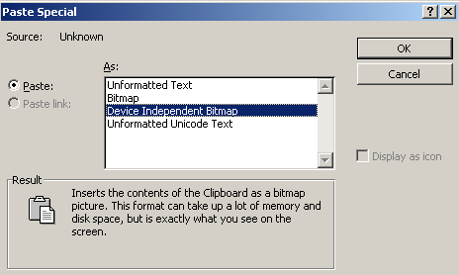
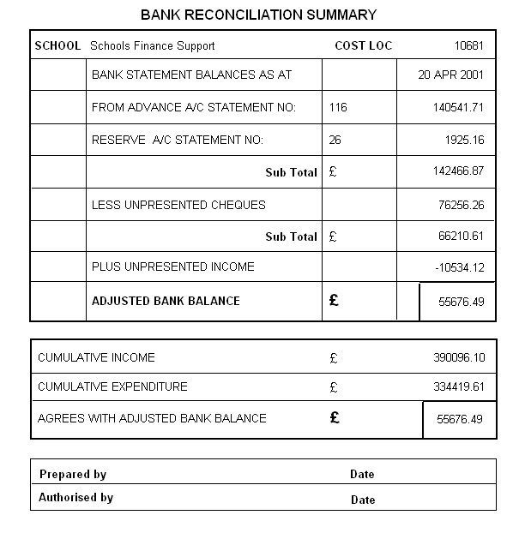

Save the copy of the bank reconciliation in the monthly returns folder as e.g. February bank reconciliation

When you have completed the above operations please ensure that you have rolled forward to the next period to ensure that the information sent to the LA is correct

Via Other Computerised Accounting Systems

Schools that use alternative computerised accounting systems should be able to transfer their Bank Reconciliation into an Excel Spreadsheet using a similar method to that above.

Manually using Bank Reconciliation E-Form
A manual bank reconciliation can be completed using the E-Form available at Appendix 3 of Section 2.6 of the Financial Guide for Schools.

When completed the Bank Reconciliation should be sent by email to the School’s Accountancy Section at schools.accountancy@barnet.gov.uk

For Audit purposes a hard copy of the bank reconciliation needs to be authorised by the
Headteacher and held on file in school

