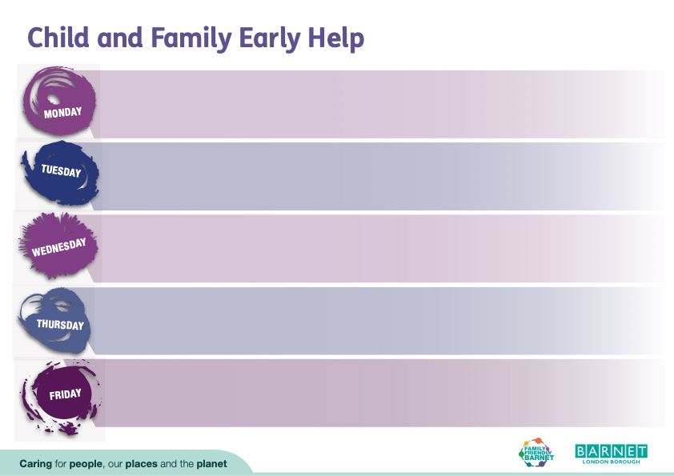

**Spring Term 09.01.24 – 31.03.23**

**Boy’s Group**

Date: 18th January – 21st March

Time: 4:00pm – 6:00pm

Barnet and Southgate College NW9 4BR

(1st Floor Colindale Campus)

**Strengthening Families Strengthening Communities (11-17yrs)**

Date: 9th January – 9th April

Time: 9:30am – 12:30pm

Venue: Barnet and Southgate College NW9 4BR (1st Floor Colindale Campus)

**Family Links (2-11yrs)**

Date: 18th January - 28th March

Time: 9.30am to 11.30am

Venue: Brunswick Park Primary School N14 5DU

**Time for Me -**

**For children who have come through living with domestic abuse (7-10yrs)**

Date: 24th January (6 weeks

Time: 4:00pm – 5:30pm

Venue: Newstead Children’s Centre N2 8LG

**Girls Group**

Date: 27th February – 30th April

Time: 4:00pm – 6:00pm

Venue: Barnet and Southgate College NW9 4BR (1st Floor Colindale Campus)

**AVA Women’s Group**

Date: 9th January 26th March

Time: 11:15am – 1.15pm

Venue: The Hyde Children’s Centre NW9 7EY

Creche Available



Working in Partnership delivering groups and 1-1 support with:

**BROOK** - Supporting young people to be safe and develop healthy relationships.

**Change Grow Live** - Supporting young people and adults with Drug and Alcohol misuse.

**Barnet Integrated Clinical Services** - Supporting young people and their families with mild to moderate Mental Health needs.

**Strengthening Learning Through Horses** - Supporting families and children offering mental health and Education services

**Home Start** - Supporting families through challenging times.

Your Family Matters – offering mediation services to families

**MENCAP** – Supporting families with children with Special Educational Need